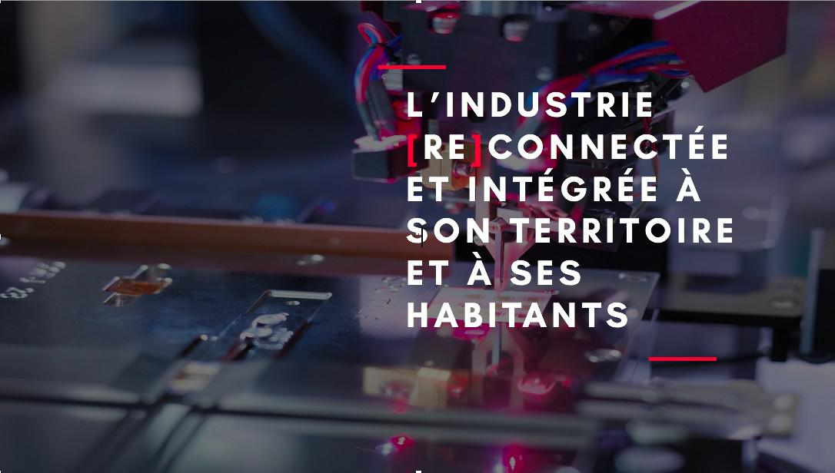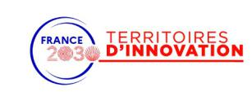

**TIGA - Action 14**

**Think and Do Tank Sciences, Sociétés et Industrie**

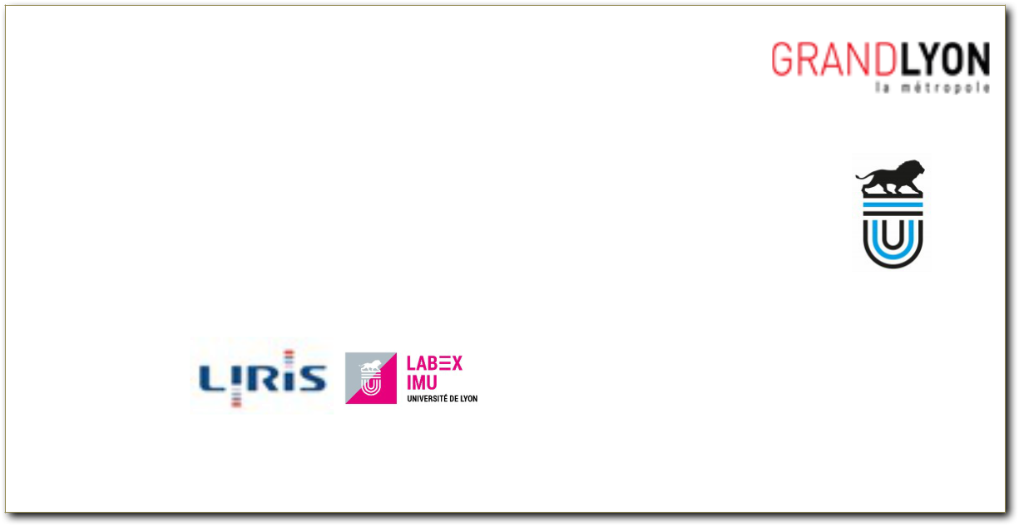

**Sous-action Médiation Augmentée**

***« Développement des outils pour la média-tion industrielle »***

Université de Lyon

Produit par Lorenzo Marnat, Gilles Gesquière et Corentin Gautier

**Juin 2022**



**Développement des outils pour la médiation industrielle**

Toutes**Nteaux**les**lecteurs**[productions](https://github.com/VCityTeam/TIGA/edit/master/doc/livrable2022.md) sont mises àdisposition en libre accès. Le code a été libéré. Il est diffusé en Open Sources [LGPL](https://www.gnu.org/licenses/lgpl-3.0.fr.html) sur ces mê%mes pages. Ce livrable est aussi proposé dans une version pdf contenant l’ensemble des informations. La première partie du document contient cette page décrivant le livrable 2022. Les contenus décrivant les composants les plus pertinents sont proposés en annexe du document pdf, mais aussi disponible sur [github](https://github.com/VCityTeam/).

2



**Table**Livrable**des**2022**matières**:Développement des outils pour la médiation industrielle 2

Note aux lecteurs 2

Introduction 4

Développement 5

Modèles 3D 5

Py3DTiles 6

Py3DTilers 6

UD-Viz 8

Couleurs et textures 8

Intégration de contenus multi-médias 9

Intégration de couches de données 2D 10

Démos UD-Viz 11

Démo Py3DTilers 11

Démo UI-driven 13

Démo Vallée de la chimie 14

Docker 15

Conclusion 16

3



La**Introduction**première étape de ce travail a consisté àproposer une veille des outils de médiation. Dans le [premier livrable](https://github.com/VCityTeam/TIGA/blob/master/doc/livrable2020.md), des expérimentations inspirantes pour le projet TIGA ont été listées et analysées. Ce deuxième livrable est dédié àdes propositions d’éléments de médiations liant numérique, territoire et jeu. Ces dispositifs sont pensés afin de favoriser l’interaction entre acteurs. Ils sont aussi conçus comme un ensemble de briques composables et réutilisables pour d’autres cas d’utilisations ou d’autres territoires.

Proposer de nouveaux outils innovants ne peut se faire que par une recherche “tirée par l’aval”; il s’agit de définir avec les partenaires un ensemble de besoins méthodologiques, scientifiques et techniques qui permettent de répondre àdes cas d’utilisations présents dans TIGA. Les propositions faites ci-dessous permettent de nourrir en particulier deux besoins. Le premier besoin est de pouvoir mieux appréhender ce qui se passe dans une zone industrielle, en faisant ressortir la ville productive, mais aussi la vie des usagers du mê%me territtoire. Ce travail a été mené avec [la mission vallée de la chimie](https://lyonvalleedelachimie.fr/la-vallee/la-mission/), le centre de formation [Interfora AFAIP](https://www.interfora-ifaip.fr/) et [TUBA : Tube àexpérimentation urbaine Lyon](https://www.tuba-lyon.com/) . Le deuxième besoin porte sur la nécessaire mobilisation de données (en particulier 3D) dans un ensemble d’outils que nous mettons àdisposition de la métropole de Lyon, en particulier de leur [Laboratoire des Usages](https://www.erasme.org/-UrbanLab-). Il s’agit de proposer des briques permettant une meilleure appropriation des données urbaines afin d’en faciliter l’utilisation par les usagers. Ces briques logicielles, issues du laboratoire [Liris](https://projet.liris.cnrs.fr/vcity/), sont présentées ci-dessous. Elle sont ensuite illustrées grâ%ce àdes cas d’utilisation.

Pour répondre àce besoin d’une meilleure compréhension du secteur industriel et du territoire par le citoyen, nous nous sommes donc orientés vers des représentations 3D numériques de la ville. La visualisation 3D d’un environnement nous permet de mieux l’appréhender et ainsi mieux discerner son organisation, ses activités, etc. Cette représentation 3D de la ville peut ê%tre améliorée en allant au-delàde la géométrie des bâ%timents. Nous voulons apporter plus de couleur et de réalisme àcette représentation pour rendre l’utilisateur plus àl’aise dans sa déambulation. De plus, afin de contextualiser un quartier ou un immeuble, nous cherchons àle lier àdes connaissances, en particulier des contenus multi-médias (photo, vidéo, texte, etc.) et apporter une nouvelle dimension la 3D, allant au délàd’une simple déambulation dans l’espace 3D. Pour ce faire, nous avons conçus différents outils utiles pour la conception de jumeaux numériques avec comme point d’entrée des données urbaines. Dans un premier temps, nous développerons les socles techniques qui ont permis la construction de représentations 3D tel que la géométrie des bâ%timents. Puis dans un second temps, nous détaillerons les démonstrations produites grâ%ce aux outils développés et qui ont pu ê%tre mis en pratique. Ces outils ont été pensés de manière reproductible avec une documentation en continue afin que ceux-ci puissent ê%tre

4



utilisables de manière autonome et également sous différentes thématiques. Le type de Licence [LGPL](https://www.gnu.org/licenses/lgpl-3.0.fr.html) facilite aussi la réutilisation des composants et outils développés.

**Développement**

|  |  |
| --- | --- |
| ***Modèles 3D*** | |
| L’intéraction avec des données urbaines nécessite de résoudre un certain nombre de | |
| problématiques, telles que la visualisation massive d’objets 3D (bâ%timents, ponts, | |
| végétation, etc) et la liaison de ces objets avec de la donnée sémantique (entendons par | |
| sémantique les données additionnelles qui viennent enrichir les données géométriques 3D; | |
| il peut s’agir d’attributs ou de façon plus général de corpus documentaires liés). L’approche | |
| que nous proposons consiste àn’appuyer au maximum sur des standards issus de [L’isso](https://www.iso.org/fr/committee/54904.html) | |
| [TC/ 211](https://www.iso.org/fr/committee/54904.html) et de l’[Open Geospatial Consortium](https://www.ogc.org/). Cela facilite l’utilisation de composants déjà | |
| existants, mais aussi la réutilisation de nos propres composants. En ce sens, nous avons par | |
| exemple fait le choix d’utiliser le standard [3D Tiles](https://github.com/CesiumGS/3d-tiles), décrit par Cesium et l’OGC. 3D Tiles a | |
| été pensé pour aider à la visualisation massive de contenu géospatial 3D. Ce standard | |
| permet de décrire un *tileset* : un arbre de tuiles 3D. Chaque tuile contient des modèles 3D | |
| auxquels sont associées des données sémantiques. Un tileset permet une organisation | |
| spatiale des tuiles, optimisée pour le rendu d’objets 3D urbains, notamment grâ%ce àla | |
| hiérarchisation spatiale des objets, mais aussi grâ%ce aux niveaux de détails. Les niveaux de | |
| détail permettent d’alterner entre des géométries plus ou moins détaillées en fonction des | |
| besoins, par exemple en affichant des modèles très simplifiés de loin (distance par rapport | |
| au point de vue) et détaillés lorsqu’on est proche. | |
| Les tuiles peuvent avoir différents formats : | |
|  | Batched 3D Model (B3DM) : Modèles 3D hétérogènes. |
|  | Instanced 3D Model (I3DM) : Instances de modèles 3D. |
|  | Point Cloud (PNTS) : Nombre massif de points colorés. |
|  | Composite : Mélange de différents formats. |

Dans les outils développés dans le cadre de TIGA, nous utilisons principalement le format B3DM. Ce format décrit les géométries àl’aide du format glTF, libre et facilitant le transfert et rendu de modèles 3D sur le web. Chaque tuile contient un ensemble de modèles 3D représentant par exemple des bâ%timents ou des arbres. Chaque modèle 3D peut-ê%tre associé àun ensemble d’informations sémantiques.

La méthode utilisée pour créer les 3D Tiles peut avoir un impact direct sur la visualisation des objets. Il est donc nécessaire de disposer d’outils permettant de tester différentes méthodes de tuilage afin d’optimiser le rendu et la visualisation des modèles 3D. Il y a aussi le besoin d’offrir àl’utilisateur des outils lui permettant de créer des 3D Tiles depuis 5



différentes données, en y ajoutant de la couleur, des textures et des niveaux de détail. C’est avec cet objectif qu’ont été développés Py3DTiles et Py3DTilers.

[***Py3DTiles***](https://github.com/VCityTeam/py3dtiles/tree/Tiler) est une librairie libre permettant de produire des 3D Tiles . Elle offre un ensemble de fonctionnalités pour écrire des 3D Tiles depuis de la donnée. Originellement développé par [Oslandia](https://gitlab.com/Oslandia/py3dtiles), et le [Liris](https://projet.liris.cnrs.fr/vcity/), cette bibliothèque a été enrichie et robustifiée au cours du projet TIGA.

Le premier objectif des modifications et ajouts apportés à Py3DTiles est de faciliter la production de modèles 3D Tiles et leur personnalisation. Pour cela, nous avons notamment ajouté le système de création d’extension : l’utilisateur peut étendre le standard afin d’y ajouter ses propres fonctionnalités. Nous avons aussi introduit dans la librairie la création de matériaux. Ces matériaux permettent de changer l’apparence des modèles 3D en y

appliquant des couleurs et des textures. Le second objectif du travail sur Py3DTiles est de s’assurer que les 3D Tiles produits avec cette librairie puissent ê%tre visualisés avec différents outils. Dans ce but, des développements ont été effectués afin de vérifier que les 3D Tiles soient fidèles au standard. Cela permet d’ê%tre certain que les 3D Tiles créés avec Py3DIiles puissent ê%tre manipulés par tous les autres outils suivant aussi le standard.

|  |  |
| --- | --- |
| [***Py3DTilers***](https://github.com/VCityTeam/py3dtilers) est un outil libre développé dans le cadre du projet TIGA. Il permet de créer des | |
| 3D Tiles depuis différents formats de données: [OBJ](https://en.wikipedia.org/wiki/Wavefront_.obj_file), [GeoJSON](https://en.wikipedia.org/wiki/GeoJSON), [IFC](https://en.wikipedia.org/wiki/Industry_Foundation_Classes) et [CityGML](https://en.wikipedia.org/wiki/CityGML). Ces formats | |
| de données sont utilisés pour représenter des données géographiques et urbaines, 2D ou | |
| 3D. Le support de ces différents formats permet de créer des 3D Tiles depuis un grand | |
| nombre de données, oùchaque donnée peut ê%tre spécialisée pour représenter des objets de | |
| la ville en particulier. Par exemple, le standard [CityGML](https://www.ogc.org/standards/citygml) permet de représenter les | |
| géométries des bâ%timents et du relief. Le standard [IFC: Industry foundation classes](https://www.buildingsmart.org/standards/bsi-standards/industry-foundation-classes/) décrit | |
| quant àlui plus en détails l’intérieur des bâ%timents. | |
| Py3DTilers se base sur la librairie Py3DTiles, décrite précédemment, pour produire des 3D | |
| Tiles. Cet outil vient rajouter des | , permettant chacun de transformer un format précis |

de données en 3D Tiles. *Py3DTilers*intègre également un grand nombre d’options et de fonctionnalités pour personnaliser la création, parmi lesquelles :

: permet d’ajouter un ou plusieurs niveaux de détail aux géométries. Cela permet de fluidifier le rendu en affichant des modèles 3D

**La créatimoinsde niveaux de détails**

plus ou détaillés.

6



|  |  |  |  |
| --- | --- | --- | --- |
|  | **La projection des données**: permet de modifier le système de projection utilisé | | |
|  | **pour** les coordonnées. Cela permet par exemple de visualiser dans un mê%me | | |
|  | contexte | des données ayant originellement des systèmes de projection différents. | |
|  | Cela permet aussi de s’adapter aux contraintes pouvant ê%tre imposées par les outils | | |
|  | de visualisation de 3D Tiles. | | |
| **La translation et mise à l’échelle des modèles 3D**: permet de transformer la | | | |
|  | donnée en changeant l’échelle ou en déplaçant les géométries. Cela permet | | |
|  | notamment de corriger les erreurs de placement ou de taille des objets dans la | | |
|  | scène. Ces fonctionnalités permettent aussi de placer de la donnée non géo- | | |
|  | référencée dans un contexte géospatial, ou inversement de placer de la donnée géo- | | |
|  | référencée àdes coordonnées centrées autour de (0, 0, 0) . | | |
|  | **L’export** | **modèle OBJ**: permet d’exporter les géométries au format OBJ. Ce | |
|  | format peut ê%tre visualisé dans la majorité des outils, ce qui permet de rapidement | | |
|  | vérifier **l’apparence** des géométries. | | |
| **L’ajout de textures**: si la donnée d’entrée est texturée, l’utilisateur peut choisir de | | | |
|  | conserver ou non les textures. Lorsque les textures sont conservées, elles sont | | |
|  | stockées dans des atlas de textures sous forme de fichiers JPEG. | | |
|  | **La création de 3D Til** | | **olorés**: permet d’ajouter des couleurs aux 3D Tiles. Les |
|  | couleurs peuvent ê%tre choisies par l’utilisateur. Les couleurs peuvent ê%tre | | |
|  | appliquées en fonction **d’attributs** des modèles (par exemple hauteur du bâ%timent) | | |
|  | ou en fonction du type des objets (toit, mur, sol, etc). | | |

Toutes les options de Py3DTilers permettent d’obtenir un outil offrant une grande polyvalence. De plus, l’architecture de code permet de rapidement ajouter des nouvelles fonctionnalités ou de personnaliser celles qui existent déjà. Py3DTilers permet à l’utilisateur un contrô%le total du processus de création de 3D Tiles, que ce soit via les options ou via la modification du code. L’outil permet de personnaliser les 3D Tiles produits, de tester de nouvelles modalités de répartition des tuiles ou de création de niveaux de détail. Py3DTilers se veut l’outil idéal pour innover ou expérimenter autour des 3D Tiles, et proposer des améliorations du standard. Cet outil est maintenant àdisposition de la communauté TIGA et permet une utilisation facilitée des modèles 3D représentant les territoires cibles de TIGA.

En complément de la documentation présente sur le dépô%t github de Py3dtilers un article scientifique a été rédigé sur Py3dTilers et ses fonctionnalités dans le cadre d’une conférence internationale ([Smart Data Smart Cities & 3D GeoInfo](https://conference.unsw.edu.au/en/sdsc-3dgeoinfo)) qui regroupe des experts de l’analyse des villes, des SIG, des jumeaux numériques, des villes intelligentes et de la science des données ([Article Py3DTilers](../Livrables/article_py3dtilers.pdf)). Cet article a été accepté pour une présentation dans la conférence internationale [3DGeoinfo](https://conference.unsw.edu.au/en/sdsc-3dgeoinfo) et sera publié dans le journal international [ISPR Annals](https://www.isprs.org/publications/annals.aspx).

7



Les 3D Tiles générés avec l’outil Py3DTilers peuvent ê%tre [visualisés avec différents logiciels](https://github.com/VCityTeam/UD-SV/blob/master/ImplementationKnowHow/Visualize3DTiles.md). Néanmoins, nous utilisons dans la majorité des cas le visualisateur [UD-Viz](https://projet.liris.cnrs.fr/vcity/tools/ud-viz/), un logiciel libre qui a été en partie développé au cours du projet TIGA.

[UD-Viz](https://github.com/VCityTeam/UD-Viz) est une librairie JavaScript permettant de visualiser de la donnée urbaine et d’intéragir avec cette donnée via navigateur Web. UD-Viz se base sur [iTowns](https://github.com/itowns/itowns), développé par l’[IGN](https://www.ign.fr/), le LIRIS étant partenaire de ces développements. iTowns permet de charger et afficher des couches de données géographiques ainsi que des modèles 3D Tiles.

Dans le cadre du projet TIGA, UD-Viz a été enrichi afin d’offrir àl’utilisateur de nouvelles interactions avec la donnée ainsi qu’un meilleur contrô%le sur l’apparence des modèles 3D. Pour cela, des développements ont été effectués afin de permettre l’intégration de contenus multi-médias et de couches de données 2D. Ces contenus permettent d’enrichir la visualisation et d’améliorer sa compréhension. De plus, le système de gestion du style des 3D Tiles a été revu afin de permettre une plus grande liberté sur l’affichage des couleurs et des textures des modèles 3D. Cela permet par exemple d’afficher des bâ%timents colorés en fonction d’un attribut (hauteur, pollution, densité, etc) ou d’afficher alternativement des modèles colorés et des modèles texturés afin d’offrir plusieurs modalités de visualisation.

|  |  |
| --- | --- |
| **Couleurs et textures** | |
| UD-Viz intègre maintenant une gestion des styles permettant d’appliquer des couleurs aux | |
| modèles des 3D Tiles. Ces styles peuvent ê%tre appliqués modèle par modèle ou àun | |
| ensemble de modèles. Auparavant, un style arbitraire était appliqué par défaut àtous les | |
| 3D Tiles lors du chargement. Le problème avec ce style par défaut est qu’il détruit les styles | |
| déjàprésents dans les modèles 3D, pour appliquer un style arbitraire àl’intégralité des | |
| modèles. En conséquence, il n’était pas possible de charger des 3D Tiles avec des textures | |
| ou des couleurs, car elles étaient détruites dès le chargement. | |
| Des modifications ont été apportées àcette gestion des styles afin de laisser àl’utilisateur | |
| le choix entre: | |
|  | Appliquer un style par défaut aux 3D Tiles lors du chargement (comme auparavant). |
|  | Conserver le style déjàprésent dans les 3D Tiles et ne pas appliquer de style par |
|  | défaut. |

La deuxième option permet une plus grande diversité des styles, puisque ces derniers ne sont plus limités àune couleur unique. De plus, les différentes options de Py3DTilers, l’outil permettant de créer les 3D Tiles, offre beaucoup d’options pour ajouter des couleurs et des textures aux 3D Tiles. Ces couleurs et textures peuvent maintenant ê%tre chargées dans UD-Viz.

8



En plus de ce travail sur le style par défaut des 3D Tiles, des modifications ont été apportées àla gestion du style dans UD-Viz afin de corriger des erreurs et de robustifier le code.

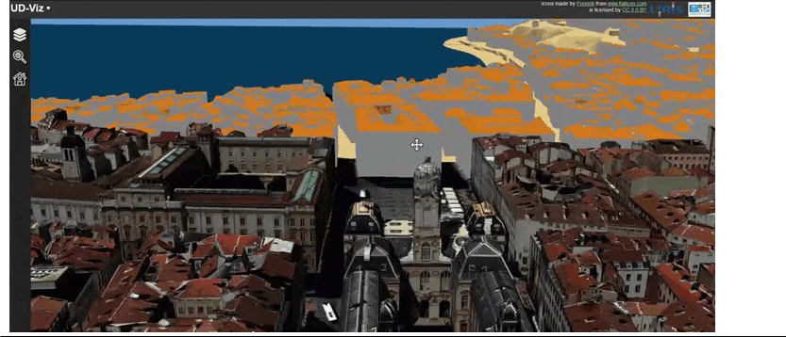

*Figure 1 : UD-viz démonstration, application des textures sur 1er arrondissement de Lyon*

|  |  |
| --- | --- |
| **Intégration de contenus ulti-médias** | |
| Afin d’améliorer la compréhension d’un territoire, nous voulions contextualiser les | |
| modèles 3D de bâ%timents avec des données multi-médias additionnelles. Ces multi-médias | |
| peuvent ê%tre des images d’archives, des vidéos d’acteurs du territoire ou des photos d’un | |
| observatoire photographique(voir par exemple le travail sur l’[Observatoire](https://www.caue69.fr/1/page/10622/Observatoire_photographique_du_paysage_sur_le_territoire_de_la_Vallee_de_la_Chimie) | |
| [photographique des paysages de la Vallée de la chimie](https://www.caue69.fr/1/page/10622/Observatoire_photographique_du_paysage_sur_le_territoire_de_la_Vallee_de_la_Chimie) mené par la mission vallée de la | |
| chimie. Ce nouveau contenu apporte une autre dimension àla déambulation dans un | |
| environnement 3D et l’améliore avec plus d’informations sur celui-ci. Nous avons donc | |
| développé une méthode d’intégration de multi-medias qui se base sur la libraire [UD-viz](https://github.com/VCityTeam/UD-Viz). | |
| (Annexe 5) L’intégration est découpée en deux parties : | |
|  | [Configuration du fichier JSON](https://github.com/VCityTeam/UD-Demo-TIGA-Webdoc-ChemistryValley/blob/main/doc/PinsDoc.md#configepisodesjson-) : documentation sur la configuration du fichier JSON |
|  | afin de lier contenus multi-medias et positions géospatiales. |

[Episode visualizer object](https://github.com/VCityTeam/UD-Demo-TIGA-Webdoc-ChemistryValley/blob/main/doc/PinsDoc.md) : programme d’intégration des multi-médias avec comme point d’entrée le fichier de configuration JSON.

9

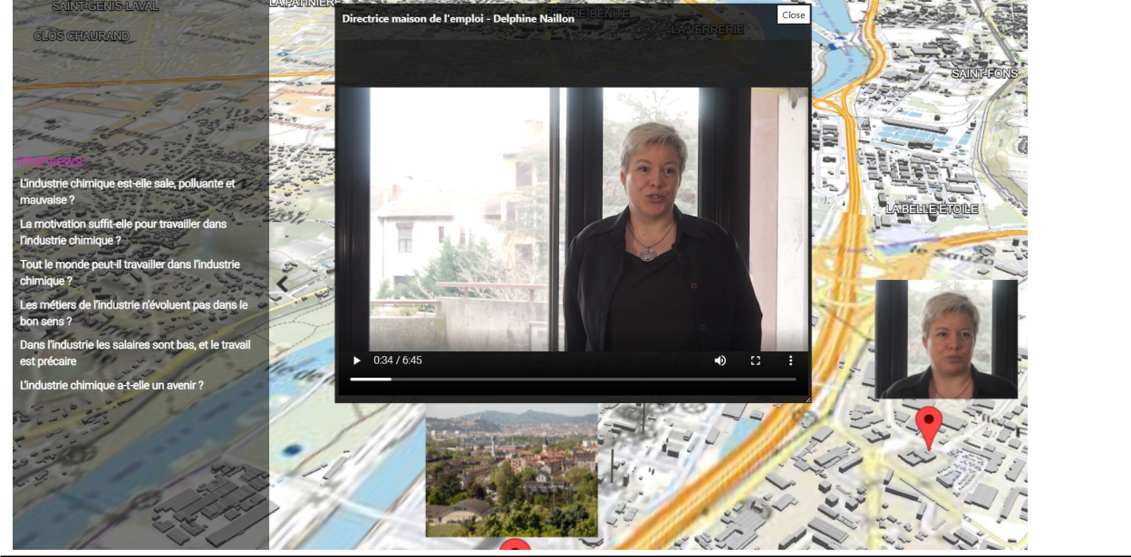

*Figure 2 : “Derrière les fumées”, intégration d’une interview de la directrice de la maison de*

Cette*l’mploi*approche*dansla* a*re*pu*résenta*ê%treutilisée*onnumérique*danslecontexte*delavallée*du web*dela*-documentaire*chimie* du projet “Derrière les fumées” (voir ci-après). Des interviews d’acteurs de la vallée de la chimie ont été disposées dans la représentation numérique de cette zone afin d’avoir plus d’informations

sur l’activité de ce territoire. Ce socle technique est documenté dans la librairie UD-Viz (Annexe 5) ainsi que dans un article scientifique sur l’intégration de multi- média dans une représentation 3D numérique soumis àla mê%me conférence internationale que Py3dTilers, [Smart Data Smart Cities & 3D](https://conference.unsw.edu.au/en/sdsc-3dgeoinfo) [GeoInfo](https://conference.unsw.edu.au/en/sdsc-3dgeoinfo) ([Article intégration de multimedia dans une représentation 3D numérique](../Livrable/Integrating_multimedia_documents_for_augmented_models_to_a_better_understanding_of_its_territory.pdf)). Cet article a été accepté pour une présentation dans la conférence internationale [3DGeoinfo](https://conference.unsw.edu.au/en/sdsc-3dgeoinfo) et sera publié dans le journal international [ISPR Annals](https://www.isprs.org/publications/annals.aspx).

Dans**Intégration**cette **de**idée**couches**d’une **de**meilleure**donnés** compréhension,**2D** au-delàd’une représentation 3D, nous nous sommes intéressés àune visualisation 2D du territoire. En effet, les données 2D urbaines apportent une nouvelle vision sur un territoire et donnent plus d’informations sur celui-ci, comme l’accessibilité de certains quartiers grâ%ce au réseau de transport en commun ou bien les zones végétalisées d’un arrondissement.

L’intégration de couches de données se fait via des services [WFS](https://www.geolittoral.developpement-durable.gouv.fr/IMG/pdf/note_explicative_wms_wfs_geolittoral.pdf) (Web Feature Service) et [WMS](https://www.geolittoral.developpement-durable.gouv.fr/IMG/pdf/note_explicative_wms_wfs_geolittoral.pdf) (Web Map service) dans la bibliothèque [UD-viz](https://github.com/VCityTeam/UD-Viz) (Annexe 5). Ce type de données nous permet de représenter différentes géométries dans UD-Viz; cela peut ê%tre des polylignes, 10



des polygones ou des images PNG/JPEG. Cet ajout de couches de données apporte une nouvelle vision àla représentation numérique et permet de contextualiser les modèles 3D de bâ%timents.

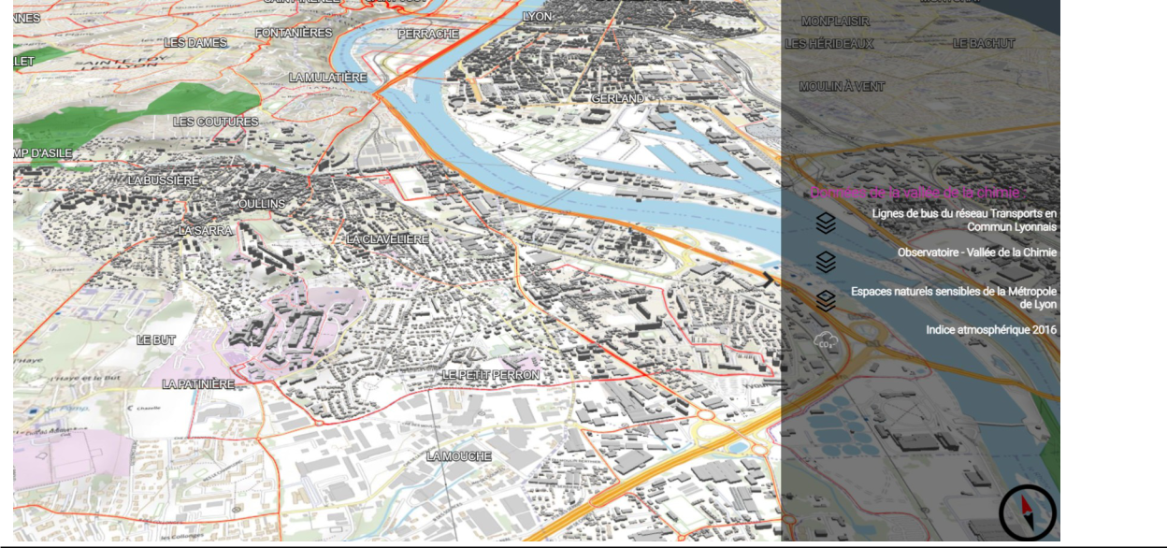

*Figure 3 : “Derrière les fumées”: intégration de données urbaines 2D tel que lignes de transports en communs (lignes rouges) et les espaces naturels sensibles de la métropole de*

Un*Lyon*cas*(polygones*d’exemple*verts)*decette*dans*intégration*lareprésetation*peutê%tre*numérique*retrouvé*de*dans*lava*la*lée*démo*dela* vallée*chimie*de la chimie avec un jeu de données 2D disponible sur le site [open data Grand Lyon](https://data.grandlyon.com/). Nous avons intégré le réseau de transport en commun pour montrer l’accessibilité àcertains sites industriels de la vallée de la chimie. Nous avons également intégré les espaces naturels sensibles pour donner une autre vision de ce territoire.

[UD](https://github.com/VCityTeam/UD-Viz-Template)***Démos***[-Viz-](https://github.com/VCityTeam/UD-Viz-Template)***UD***[Template](https://github.com/VCityTeam/UD-Viz-Template)***-Viz*** est un template d’application permettant de créer rapidement des démonstrations basées sur la librairie UD-Viz (Annexe 5). Ces démonstrations permettent d’illustrer des fonctionnalités et/ou des données particulières. Grâ%ce à ce template, différentes démonstrations ont pu ê%tre réalisées afin d’alimenter le projet TIGA. En voici la liste présentée ci-dessous :

**Démo Py3DTilers**Codesource de la démonstration ainsi que sa documentation.

Docker pour reproduire l’application.

11



Démo en ligne

Cette démo propose un ensemble de 3D Tiles créés avec les outils de Py3DTilers. On y retrouve des 3D Tiles de bâ%timents, ponts, relief et cours d’eau, certains texturés et d’autres colorés.

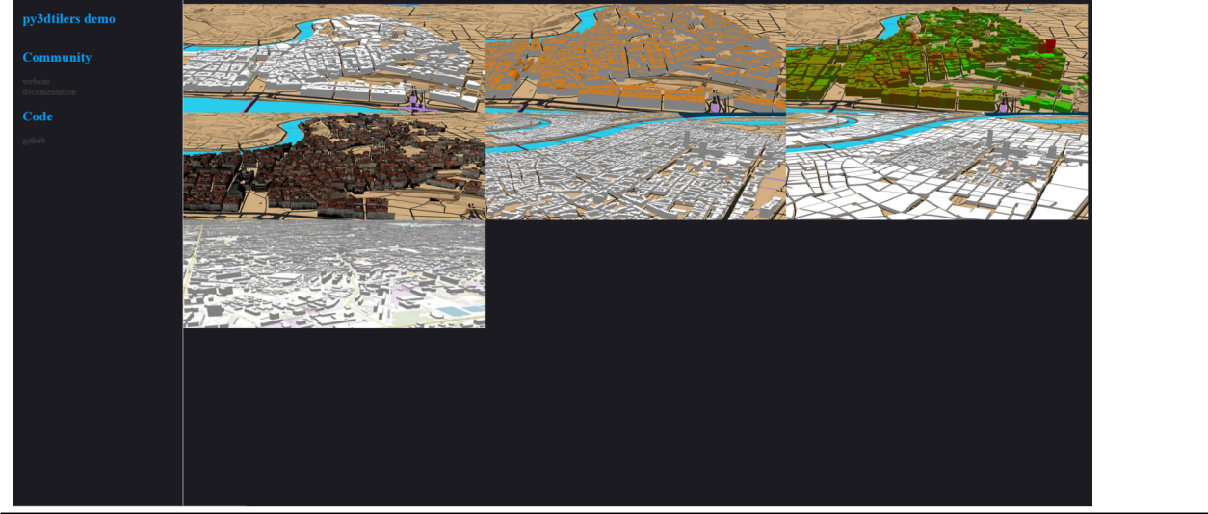

*Figure 4 : Mosaïques des différentes démonstrations développées grâce à l’outil Py3tilers. Une démonstration de la ville texturée, une autre avec de la couleur, la ville avec différents niveaux de détail..*

Les 3D Tiles ont été créés àpartir de couches de données publiques issues du site du [Grand](https://data.grandlyon.com/) [Lyon](https://data.grandlyon.com/) et de l’ [IGN](https://geoservices.ign.fr/telechargement). Les modèles 3D des ponts et du relief sont créés àpartir de la donnée CityGML du Grand Lyon, par l’intermédiaire d’une [base de données 3DCityDB](https://github.com/VCityTeam/UD-SV/blob/master/ImplementationKnowHow/PostgreSQL_for_cityGML.md). Les fleuves et les routes sont créés àpartir des données GeoJSON de l’IGN. Les bâ%timents sont quant à eux créés soit à partir des fichiers CityGML soit à partir de fichiers GeoJSON. Une [documentation](https://github.com/VCityTeam/UD-Reproducibility/blob/master/Computations/3DTiles/Lyon_Relief_Roads_Buildings_Water/Compute_Lyon_3DTiles.md) a été créée pour expliquer plus en détails le processus de création des 3D Tiles depuis de la donnée publique.

La démo introduit aussi de nouvelles modalités de visualisation des 3D Tiles. Elle implémente notamment un nouveau fonctionnement des niveaux de détails des modèles 3D. Par défaut, le niveau de détails se raffine en fonction du zoom (position par rapport àla caméra) : plus la caméra est proche d’un modèle, plus ce dernier est détaillé. Ici, on offre la possibilité d’utiliser la souris comme une “loupe”: les modèles proches de la souris de l’utilisateur sont raffinés afin d’obtenir des modèles plus détaillés sans avoir besoin de bouger la caméra.

12

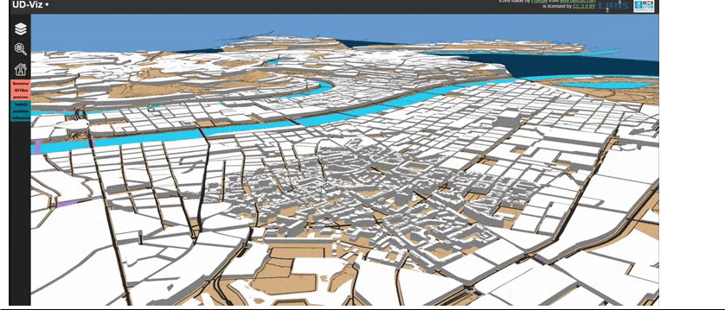

*Figure 5 : Démonstration montrant le raffinement du niveau de détail des bâtiments de Lyon en fonction de la position de la souris*

**Démo UI**Code**-riven**source de la démonstration ainsi que sa documentation.

Docker pour reproduire l’application.

Démo en ligne

Cette démo permet de calculer la hauteur de routes en les plaçant sur le relief. Pour cela, les routes doivent ê%tre contenues dans des fichiers GeoJSON. Ces fichiers peuvent ensuite ê%tre glissés/déposés dans la démonstration. Les routes seront affichées au fur et àmesure du calcul. Une fois toutes les routes placées sur le relief, de nouveaux fichiers GeoJSON contenant les routes aux bonnes altitudes sont téléchargés. Le processus pour créer des routes 3D àpartir de donnée de l’IGN est détaillé dans cette [documentation](https://github.com/VCityTeam/UD-Reproducibility/blob/master/Computations/3DTiles/Lyon_Relief_Roads_Buildings_Water/Roads_from_relief.md).

13

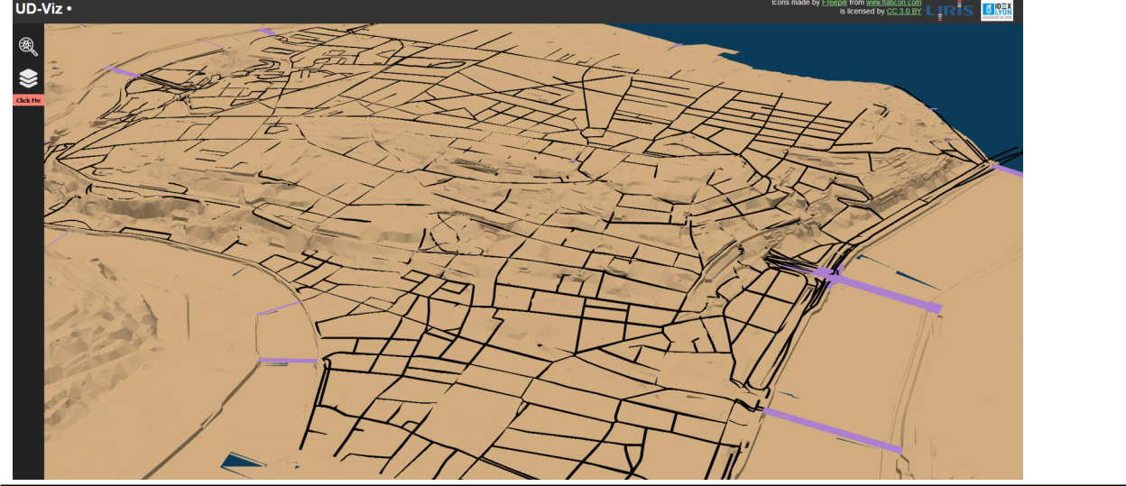

*Figure 6 : Démo UD -Viz sur le calcul des hauteurs de routes contenu dans un fichier GeoJSON à l’aide d’un glisser/déposer dans l’application web UD-Viz*

|  |  |
| --- | --- |
| ***Démo Vallée de la chimie*** | |
| Une expérimentation de ces outils aidant àla représentation numérique d’un territoire et la | |
| démo [Vallée de la chimie](https://fr.wikipedia.org/wiki/Vall%C3%A9e_de_la_chimie) qui a été développé dans le cadre d’un web-documentaire en | |
| collaboration avec [la missions vallée de la chimie](https://lyonvalleedelachimie.fr/la-vallee/la-mission/) , le centre de formation [Interfora AFAIP](https://www.interfora-ifaip.fr/) et | |
| [TUBA : Tube àexpérimentation urbaine Lyon](https://www.tuba-lyon.com/). Ce projet “Derrière les fumées” a pour but de | |
| déconstruire les idées préconçues que peuvent avoir les citoyens de la métropole de Lyon | |
| sur ce territoire. Dans cette problématique, nous nous sommes orientés vers une | |
| représentation numérique de la vallée de la chimie pour mieux la comprendre et y disposer | |
| du contenu multi-média afin d’apporter plus d’informations. Grâ%ce àl’outil d’intégration de | |
| multi-média dans la bibliothèque UD-Viz (Annexe 5), nous avons pu disposer des | |
| d’interviews d’acteurs de ce territoire et des données urbaines dans la maquette | |
| numérique. Ces différents éléments sont disposés àdes points d’intérê%t en lien avec le | |
| thème de l’industrie. | |
|  | [Code](https://github.com/VCityTeam/UD-Demo-TIGA-Webdoc-ChemistryValley) source de la démonstration ainsi que sa documentation. |
|  | [Docker](https://github.com/VCityTeam/UD-Demo-TIGA-Webdoc-ChemistryValley-docker) pour reproduire l’application. |
|  | [Démo en ligne](https://www.derrierelesfumees.com/_Contenusdlf/Carte/index.html) |

14

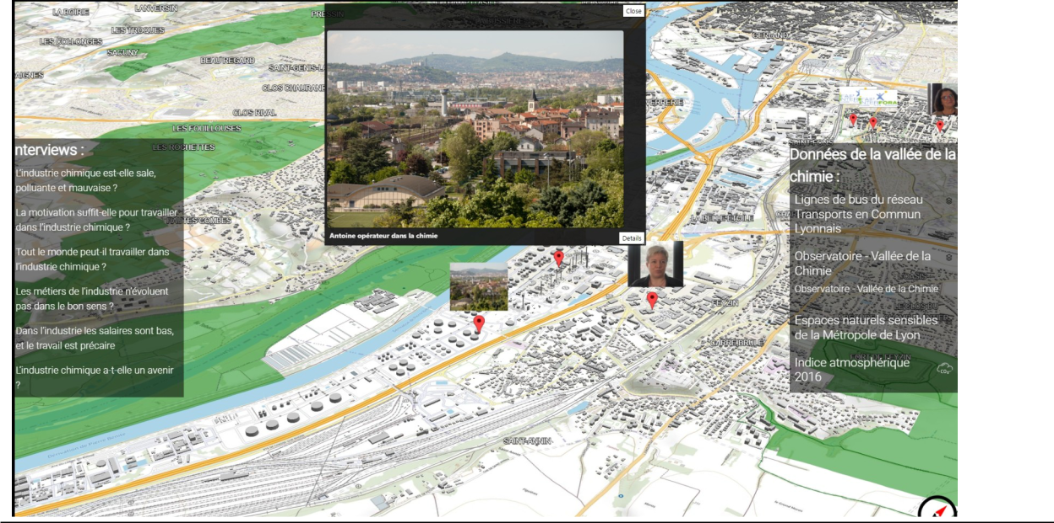

*Figure 7 : Capture du web -documentaire “Derrière les fumées”, avec les deux panneaux d’affichages, les différentes interviews d’acteurs de la vallée de la chimie et les données*

Pour*urbaines*produire*récupérées*cette *sur*démonstration*l’pendataGrand*nous *Ly*avons récupéré les données CityGML disponibles sur l’open data Grand Lyon pour ensuite les traiter avec Py3DTilers et générer les 3D Tiles ([3D Tiles générés avec Py3DTilers](https://dataset-dl.liris.cnrs.fr/three-d-tiles-lyon-metropolis/Demo/UD-Demo-vcity-py3dtilers-lyon/) : bâ%timents, relief, routes, ponts, fleuves ) de la vallée de la chimie. En complément de ces modèles 3D, nous avons intégré les [photos de](https://umap.openstreetmap.fr/fr/map/vallee-de-la-chimie-observatoire-photographique_233823#18/45.68050/4.86110) [l’observatoire de la vallée de la chimie](https://umap.openstreetmap.fr/fr/map/vallee-de-la-chimie-observatoire-photographique_233823#18/45.68050/4.86110) produites par Florent PERROUD et les images d’archives de la catastrophe de Feyzin en libre accès sur le site la bibliothèque municipale de Lyon ([lien des photos](https://numelyo.bm-lyon.fr/BML:BML_01ICO001015c33b77d0036c?&collection_pid=BML:BML_01ICO00101&luckyStrike=1&query%5B%5D=isubjectgeographic:%22Feyzin%20(Rh%C3%B4ne)%22&hitPageSize=1&hitTotal=62&hitStart=24)).

Docker est un outil permettant de lancer des applications dans un contexte déterminé et isolé. Les applications ne sont ainsi pas exécutées directement sur la machine hô%te, mais dans un contexte maî%trisé. Une application contenue dans un Docker sera toujours exécutée de la mê%me manière, les versions des différents composants sont figées. Cela permet de s’assurer que l’application pourra ê%tre utilisée sur n’importe quelle machine, sans souci d’installation et sans erreur de version des logiciels. L’utilisation de Docker permet d’éviter qu’une application fonctionnelle ne devienne inutilisable après quelque temps àcause de mise àjour de la machine hô%te ou de l’application elle-mê%me.

15



contenuesC’estpourquoidanstoutesdes Dockers.lesapplicationsAinsi, développéesons’assure lorsdeladupérennitéprojetpossèdentdansledestempsversionsdes applications en plus d’ê%tre certains qu’elles pourront ê%tre lancées sur toutes les machines.

[UD](https://github.com/VCityTeam/UD-Viz-docker)UD[-](https://github.com/VCityTeam/UD-Viz-docker)-[Viz](https://github.com/VCityTeam/UD-Viz-docker)Demo[-Docker](https://github.com/VCityTeam/UD-Viz-docker)-TIGA-Webdoc-ChemistryValley-Docker

UDUD--DemoDemo--VCityvcity--py3dtilersUI-driven--datalyon--computationDocker-Lyon-Docker

Chaque docker listé est une application des différents outils développés dans le cadre du projet TIGA.



**Conclusion**Depuisledébut du projet TIGA, l’action 14 “THINK & DO TANK Sciences, Sociétés et Industrie” permet de favoriser les échanges entre partenaires. Après un [travail de veille](https://github.com/VCityTeam/TIGA/blob/master/doc/livrable2020.md) qui a donné lieu au premier livrable en tout début de projet TIGA, et une phase d’échange au sein de cette action, il s’est agit de proposer un ensemble de composants permettant le développement de nouvelles modalités de médiation pour aider àla reconnexion entre Industrie, citoyen et territoire. La veille nous a permis de nous orienter vers ces premiers outils de médiation dans le but de rapprocher les différents acteurs du territoire de la métropole de Lyon.

Dans ce deuxième livrable, nous avons cherché àvoir comment des représentations 3D pouvaient venir en interface entre le territoires et les usagers. Les différents outils ont permis la création de nouvelles représentations numériques 3D en y apportant une nouvelle dimension grâ%ce aux multi-médias et ainsi de les éprouver sur des problématiques en lien avec l’industrie. Chaque application est développée grâ%ce à un ensemble de composants atomiques mis àdisposition des acteurs TIGA, mais aussi plus généralement d’une communauté plus large afin d’en assurer une meilleure dissémination. Au delàdu code, il s’est agit de proposer une documentation liée, ainsi que des dockers afin que tout le monde puisse utiliser les composants sur son propre environnement de travail et répondre au besoin de reproductibilité. Les composants sont conçus de façon atomique afin de pouvoir les composer en fonction des besoins et assurer une meilleur réutilisabilité, mais aussi réplicabilité.

Ces composants ont été mis en place afin de proposer une nouvelle modalité d’accès aux contenus via le territoire dans le cadre du web doc “Derrière les fumées” mis en place en collaboration avec [la missions vallée de la chimie](https://lyonvalleedelachimie.fr/la-vallee/la-mission/), le centre de formation [Interfora AFAIP](https://www.interfora-ifaip.fr/) et [TUBA : Tube àexpérimentation urbaine Lyon](https://www.tuba-lyon.com/).

16



Une autre application de ces composants est faite sur les “maquettes tangibles”, élément d’hybridation entre maquette physique du territoire et contenu numérique. Elle sera décrite dans un prochain livrable. Grâ%ce àl’intégration d’images d’archives dans un jumeau numérique de ville nous avons abordé l’évolution temporelle de la ville. Nous voulons aller plus loin et développer plus en profondeur ce cô%té évolutif pour mieux comprendre comment un territoire est devenu ce qu’il est actuellement. Ce projet Morphogenèse se veut focalisé sur l’évolution du travail de 1950 àaujourd’hui et est le prochain objectif du LIRIS dans le contexte du projet TIGA, en collaboration avec le laboratoire [Environnement Ville et](https://umr5600.cnrs.fr/fr/accueil/) [Société](https://umr5600.cnrs.fr/fr/accueil/). Il viendra aussi compléter le prochain livrable que le LIRIS aura àproduire dans les prochains mois dans le cadre du projet TIGA.

17



**Annexe 1**

**Compute Lyon 3DTiles**

This document explains how to create 3DTiles models of buildings, relief, roads, bridges and water bodies from Lyon’s open data with py3dtilers.

To be able to use the Tilers from py3dtilers, follow the [installation notes](https://github.com/VCityTeam/py3dtilers#installation-from-sources).

**Geojson Tiler**

Download**Rads** the BD Topo data from IGN

In [QGIS](https://www.qgis.org/en/site/), open the file.

You*BDTOPO/1*canfilter*DONNEES*roads,for*LIVRAISON/TRANSPORT/*examplebykeepingthose***TRONCON***starting***_***or***DE***ending***ROUTE***in***.shp***Lyon 1er:

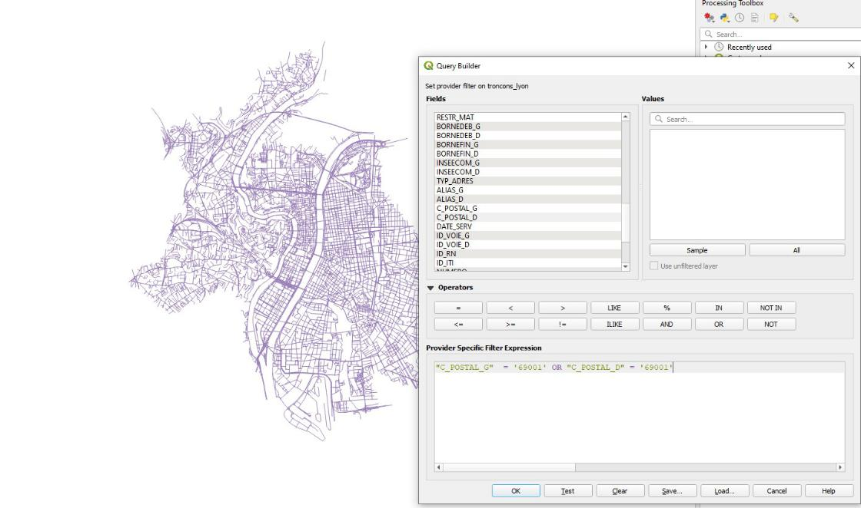

Then,*qgisfilter*save*road*theroads layer as a GeoJson file:

18

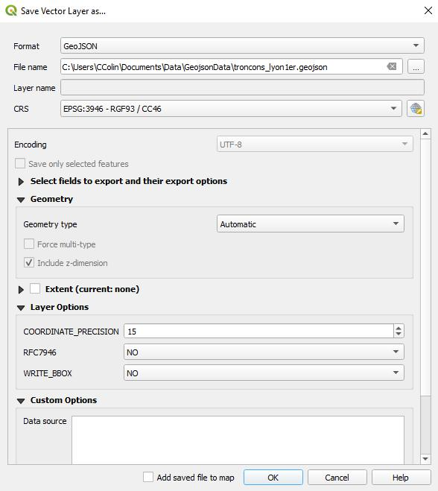

To*qgis*create*save_*roads*layer* 3DTiles with the [GeoJsonTiler](https://github.com/VCityTeam/py3dtilers/tree/master/py3dtilers/GeojsonTiler), run:

geojson-tiler --path path/to/troncons_lyon1er.geojson --height 0.5

19



The height argument set how thick are your roads (in meters). You can set it to an arbitrary value.

You can also set the width of your roads with . By default, the

GeoJsonTiler targets the property in geojson--widthfeatures<float>to find the width; the

property to target can be changed LARGEURwith .

See the [GeojsonTiler README](https://github.com/VCityTeam/py3dtilers/blob/master/py3dtilers/GeojsonTiler/README.md) for more --informationwidthOTHERon_usagePROP_.NAME

Download**Waterboies**the BD Topo data from IGN

In [QGIS](https://www.qgis.org/en/site/), open the file.

You*BDTOPO/1*canselect*DONNEES*onlythe*LIVRAISON/HYDROGRAPHIE/*partsyouneed:***SURFACE_HYDROGRAPHIQUE.shp***

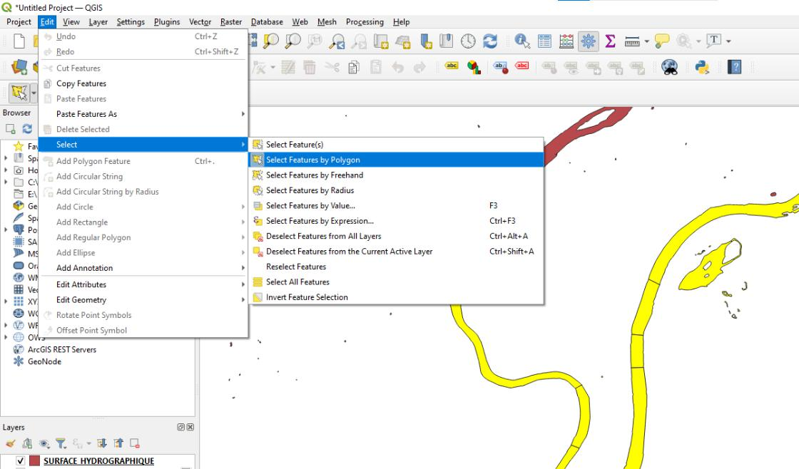

Then,*selct_*save*hydro*the*su*roads*fce* layer as a GeoJson file:

20

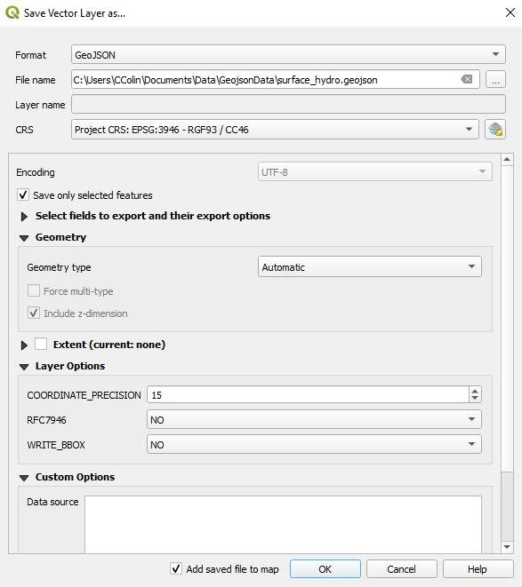

To*qgis*create*save_*3DTiles*hydro* with the [GeoJsonTiler](https://github.com/VCityTeam/py3dtilers/tree/master/py3dtilers/GeojsonTiler), run:

geojson-tiler --path path/to/surface_hydro.geojson --height 0.5

21



The height argument set how thick are your water bodies (in meters). You can set it to an arbitrary value.

See the [GeojsonTiler README](https://github.com/VCityTeam/py3dtilers/blob/master/py3dtilers/GeojsonTiler/README.md) for more information on usage.

Creating**ityGML**3DTiles**Tiler** with the [CityGML Tiler](https://github.com/VCityTeam/py3dtilers/tree/master/py3dtilers/CityTiler) require [Postgres/PostGIS](https://www.enterprisedb.com/downloads/postgres-postgresql-downloads) and [3DCityDB](https://www.3dcitydb.org/3dcitydb/downloads/). The cityGML data must be hosted in a 3DCityDB database to be used by the CityGML Tiler.

To host cityGML in database, you can follow (recommended) or use the

[docker](https://github.com/VCityTeam/UD-SV/blob/master/Install/Install3DCityDB.md#1a-installing-a-3dcitydbpostgis-server-the-docker-deployment-case) (may be outdated). [**this tutorial**](https://github.com/VCityTeam/UD-SV/blob/master/ImplementationKnowHow/PostgreSQL_for_cityGML.md) You should also copy the configuration file (for example

thispy3dtilers/CityTiler/CityTilerDBConfignewfile..yml) and add the details of your database in

Download**Buildings** the cityGML data from [Data Grand Lyon](https://data.grandlyon.com/jeux-de-donnees/maquettes-3d-texturees-2018-communes-metropole-lyon/info) (you can choose which districts of Lyon you want to download). Then, import the buildings into a 3DCityDB database:

22

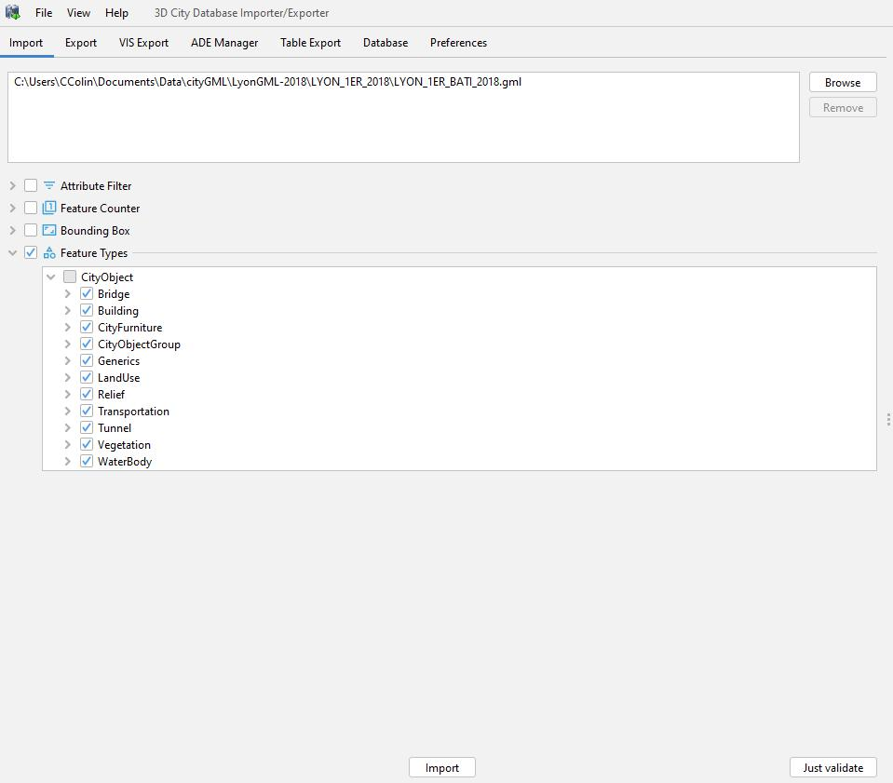

To*import*use*_*the*buildings*Tiler, target your database config file and choose the type (see the

[CityTiler usage](https://github.com/VCityTeam/py3dtilers/blob/master/py3dtilers/CityTiler/README.md) for more details): building

Tocitygmlcreate- tiler[LOA](https://github.com/VCityTeam/py3dtilers/blob/master/py3dtilers/CityTiler/README.md#loa),you--dbcanconfigforexamplepath use<path_to_file>/Config.yml --type building from BD Topo

(*BDTOPO/1*[IGN](https://geoservices.ign.fr/telechargement)).Tobe*DONNEES*abletouse*LIVRAISON/ADMINISTRATIF/*it,exportthe.shpasGeoJson***ARROND***withQGIS***SEMENT***(theprojection***.shp*** must be the same as buildings, i.e EPSG:3946 most of the time for Lyon’s data).

To create the 3DTiles with levels of detail, run:

23



citygml-tiler --db_config_path <path_to_file>/Config.yml --lod1 --loa polygons.geojson

Download**Relief** the cityGML data from [Data Grand Lyon](https://data.grandlyon.com/jeux-de-donnees/maquettes-3d-texturees-2018-communes-metropole-lyon/info) (you can choose which districts of Lyon you want to download). Then, import the relief into a 3DCityDB database:

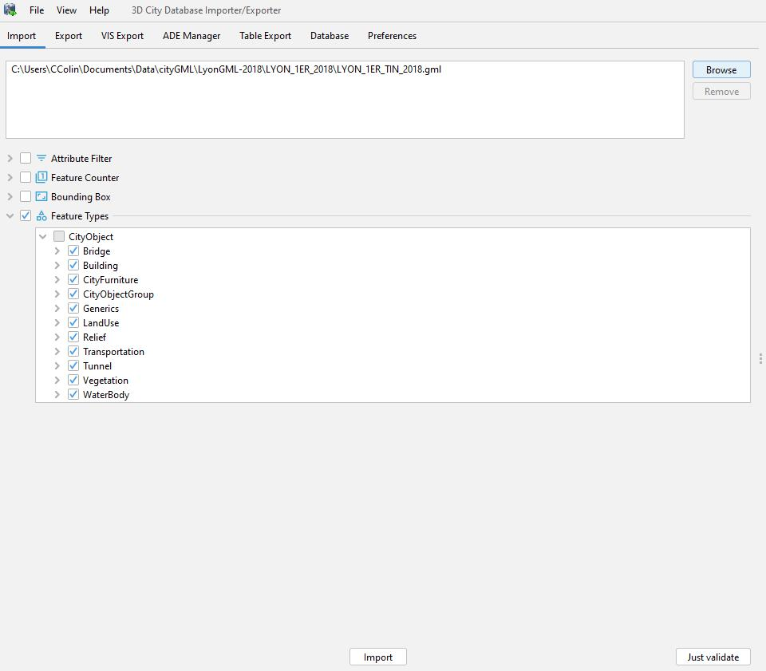

To*import*use*_*the*relief*Tiler, target your database config file and choose the type (see the

CityTiler usage for more details): relief

To create the relief as 3DTiles, run:

citygml-tiler --db_config_path <path_to_file>/Config.yml --type relief

24



Download**Bridges** the cityGML data from [Data Grand Lyon](https://data.grandlyon.com/jeux-de-donnees/maquettes-3d-texturees-2018-communes-metropole-lyon/info) (you can choose which districts of Lyon you want to download). Then, import the bridges into a 3DCityDB database:

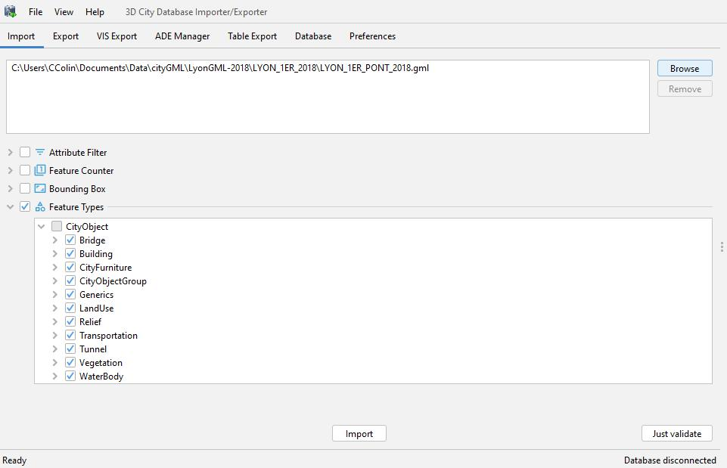

To*import*use*_*the*bridges*Tiler, target your database config file and choose the type (see the

CityTiler usage for more details): bridge

To create the bridges as 3DTiles, run:

citygml-tiler --db_config_path <path_to_file>/Config.yml --type bridge

25



**Annexes 2**

**Pins**Objet**documentation**3Dinteractifpointant sur des centres d’intérets dans la scène 3D de UD-Viz (Annexe 5). Ces éléments interactifs sont representés par une bulle d’image ainsi qu’une épingle ; l’image permet de donner un aperçu sur le contenu qui sera afficher si l’utilisateur intéragit avec en cliquant sur celui-ci.

Chacun de ces éléments est un contenu d’un épisode et un épisode comprends plusieurs contenus. Ce contenu permet de détailler une zone spécifique sur une maquette en y ajoutant du texte ou une image.



Un**Technical**pinest**details**uncontenu d’un épisode qui est matérialisé par la classe et contient toutes les informations sur un contenu d’un épisode. La classeEpisdoncdeContent.js

comprend la liste des contenus de l’épisode et une liste d’objetEpisodeVisualizer.js qui apparaissent dans la scène 3D.

EpisodeContent



Le*configEpisodes*configEpisodes*.json*.json*:* est le fichier JSON qui permet de configurer tout le contenu de votre épisode. C’est ici que vous allez modifier les sources d’images, sa position etc… et doit suivre le template suivant :

: L’élément 3D peut ê%tre vérrouillé ou dévérouillé en fonction de sa valeur dans lelockfichier de config. Cette valeur dépend d’ou se trouve l’utilisateur dans le

visionnage d’un épisode. Le contenu pourra ê%tre accessible que si celui-ci a une valeur à**false**:laposition georéférence dans votre scène avec son type de projection

(EPSG:3946)position.

: le chemin en direction votre image dévérouillé.

imgUnLock:le chemin en direction votre image vérouillé.

26



Une fois dévérouillé, l’épingle est accessible et intéractive pour afficher le contenu de ce point d’intéret plus en détail. Une fenê%tre html apparait et donne une description de la zone que pointe l’élément.



Exemple*Codeexample*decode pour créer 3 contenu d’un épisode et l’afficher dans la scène.

**let** content_1 = **new** EpisodeContent(configEpisode['episode-1-data'] ['content-1']);

**let** content_2 = **new** EpisodeContent(configEpisode['episode-1-data'] ['content-2']);

**let** content_3 = **new** EpisodeContent(configEpisode['episode-1-data'] ['content-3']);

**let** listContents = [content_1,content_2,content_3];

**const** episode_1 = **new** EpisodeVisualizer('episode_1', view3D, listContents);

episode_1.constructAllContent();

27



**Annexe 3**

**Python 3DTiles Tilers**

p3dtilers is a Python tool and library allowing to build tilesets out of various geometrical formats e.g. OBJ, GeoJSON, IFC or CityGML [3D](https://github.com/AnalyticalGraphicsInc/3d-tiles)through[Tiles](https://github.com/AnalyticalGraphicsInc/3d-tiles)3dCityDB databases.

p3dtilers uses [python library](https://github.com/VCityTeam/py3dtiles/tree/Tiler) (forked from [Oslandia’s py3dtiles](https://gitlab.com/Oslandia/py3dtiles)) for its in memory representation[py3dtiles](https://github.com/VCityTeam/py3dtiles/tree/Tiler)of tilesets.

py3dtilers can only produce . If you want to produce

[Clouds (PNTS)](https://github.com/CesiumGS/3d-tiles/blob/main/specification/TileFormats/PointCloud/README.md), see [Oslandia’s](https://gitlab.com/Oslandia/py3dtiles/-/blob/master/docs/cli.rst)Batched[py3dtiles](https://gitlab.com/Oslandia/py3dtiles/-/blob/master/docs/cli.rst)3D [CLI](https://gitlab.com/Oslandia/py3dtiles/-/blob/master/docs/cli.rst)Models. (B3DM) Point

**CLI Features**ObjTiler: converts OBJ files to a 3D Tiles tileset

GeojsonTiler: converts GeoJson files to a 3D Tiles tileset

IfcTiler: converts IFC files to a 3D Tiles tileset

CityTiler: converts CityGML features (e.g buildings, water bodies, terrain…)

extracted from a 3dCityDB database to a 3D Tiles tileset

[TilesetReader](../../py3dtilers/py3dtilers/TilesetReader): read, merge or transform 3DTiles tilesets

**Installation from sources**

Install**ForUnix**binary sub-dependencies with your platform package installer e.g. for Ubuntu use

apt-get install -y libpq-dev *# required usage of psycopg2 within*

*py3dtilers*

Firstapt installcreatea safepython3[python](https://docs.python.org/3/tutorial/venv.html)python3[virtual](https://docs.python.org/3/tutorial/venv.html)-[environment](https://docs.python.org/3/tutorial/venv.html)pip*#Pyth*(not*n3*mandatory*versin must*yetquite*be* recommended)*<=3.9*

apt install virtualenv

virtualenv -p python3 venv

. venv/bin/activate

Then,**(**vv **)**depending$ on your use case, proceed with the installation of py3dtilers per se

28



Point**py3dtilers**pipdirectly**usage**to**use**github**case** :(sources) repository with

**(**venv**)**$ pip install git+https://github:.com/VCityTeam/py3dtilers.git

Download**py3dtilers**py3dtilers**developers**sources**secase**onyour host and install them with pip:

apt install git

git clone https://github.com/VCityTeam/py3dtilers cd py3dtilers

**(**venv**)**$ pip install -e .

Install**ForWindows**python3 ( ).

In order to install**<=py3dtilers.9** from sources use:

git clone https://github.com/VCityTeam/py3dtilers

cd py3dtilers

python3 -m venv venv

. venv/Scripts/activate

**(**venv**)**$ pip install -e .

**About IfcOpenShell**:make**dependency**sure,that the IfcOpenShell dependency was properly installed with

help**Caveat**of the**emptor** command. In case of failure of the importationpythontryre-installing-c'importbut ifcopenshell'thistimewiththe verbose flag, that is try

and**(**venvlook**)**$ forpiptheinstalllinesconcerning-e.-v IfcOpenShell.

**Usage**Inorder to access to the different flavors of tilers, refer to the corresponding readmes to discover their respective usage and features:

CityTiler readme

GeojsonTiler readme

ObjTiler readme

IfcTiler [readme](../../py3dtilers/py3dtilers/IfcTiler/README.md)

29



TilesetReader readme

Useful tutorials:

CityTiler usage example

GeojsonTiler usage example

Visualize 3DTiles in Cesium, iTowns or UD-Viz (Annexe 5)

Create 3DTiles from OpenStreetMap data

Host CityGML data in 3DCityDB

**Develop with py3dtilers**

After**Running**the**the**installation,**ests(pt**if**onal)**you additionally wish to run unit tests, use

**(**venv**)**$ pip install -e .[dev,prod]

To**(**venvrun**)**$CityTiler’spytest tests, you need to install PostgreSQL and Postgis.

To setup PostgreSQL with Postgis on Windows, follow the first step (1. Download PostgreSQL/PostGIS) of 3DCityDB tutorial.

For Ubuntu, follow [this tutorial](https://github.com/VCityTeam/UD-SV/blob/master/Install/Setup_PostgreSQL_PostGIS_Ubuntu.md).

First,**Coding**install**style** the additional dev requirements

To**(**venvcheck**)**$ ifpiptheinstallcodefollows-e.the[dev]coding style, run flake8 You**(**venvcan**)**$ fixflake8most of. the coding style errors with autopep8

If**(**venvyou **)**want$autopeapply8 --in-placefrom--rootecursivedirectory,p3dtilers/excludethe *venv* directory autopep8

**(**venv**)**$ autopep8 --in-place --exclude='venv*' --recursive .

30



By**Developing**default, the**py3dtilers**py3dtilers’**together with py3dtiles**buildstage uses [github’s version of py3dtiles](https://github.com/VCityTeam/py3dtiles) (as

aopposedlocalversiontousingof py3dtilesOslandia’s[setup](https://github.com/VCityTeam/py3dtilers/blob/master/setup.py#L30)(locatedversion[.py](https://github.com/VCityTeam/py3dtilers/blob/master/setup.py#L30) onon hostPypiin.Whenanotherdevelopingdirectoryonee.g.mightbycloningneed/wishtheoriginaltouse repository) it is possible

to first install py3dtiles by following the [installation notes](https://github.com/Oslandia/py3dtiles/blob/master/docs/install.rst)

referencethenwithintothepy3dtilespy3dtilers. (cloned) directory, comment out (or delete) the line

This boils down to :

* git clone https://github.com/VCityTeam/py3dtiles
* cd py3dtiles
* ...
* source venv/bin/activate **(**venv**)**$ cd ..

**(**venv**)**$ git clone https://github.com/VCityTeam/py3dtilers

**(**venv**)**$ cd py3dtilers

**(**venv**)**$ *# Edit setup.py and comment out py3dtiles reference*

**(**venv**)**$ pip install -e .

**(**venv**)**$ pytest

**Concerning**For developers,**CityTiler** some [design notes](../../py3dtilers/docs/Doc/CityTilerDesignNotes.md)

LIRIS,Credentials:UniversityCityTilerofLyon,originalFrance)code is due to Jeremy Gaillard (when working at

**Configuri g your IDE**

runWhen(e.g.configuringpy3dtilers.CityTiler.CityTiler)yourIDEtorunaspecificandnottiler,theyoupathmusttotheindicatefile(i.e.thenotmodule$ you want to {workspace_root}/py3dtilers/CityTiler/CityTiler.py), otherwise python will not be able to

ofresolvelaunchtheconfigurationrelativeimportinVSCode:oftheTilers to the Common package of py3dtilers. An example

{

"version": "0.2.0",

"configurations": [

{

"name": "<launch_config_name>", **// e.g.** "CityTiler" **or** "bozo"

"type": "python",

"request": "launch",

31



"module": "<tiler_module>", **// e.g.**

**py3dtilers.CityTiler.CityTiler**

"args": ["--db_config_path",

"${workspaceRoot}/py3dtilers/CityTiler/<my_config_file.yml>"],

"console": "integratedTerminal"

}

]

}

Python**rofilig**standard module [cProfile](https://docs.python.org/3/library/profile.html) allows to profile Python code.

Import***ncode*** modules:

import cProfile

Profileimport thepstatscode between enable() and disable():

cp = cProfile.Profile()

cp.enable() *# Start profiling*

*# code here*

cp.disable() *# Stop profiling*

p = pstats.Stats(cp)

p.sort_stats('tottime').print_stats() *# Sort stats by time and print them*

cProfile***Incmmand***can be***line***run in the shell with:

python -m cProfile script.py

32



**Annexe 4**

**py3dtilers demo**

This demo illustrate [3D Tiles](https://github.com/CesiumGS/3d-tiles) tilesets created with [py3dtilers](https://github.com/VCityTeam/py3dtilers). The demo is based on [UD-Viz](https://github.com/VCityTeam/UD-Viz) (Annex 5) which is using [iTowns](https://github.com/iTowns/itowns/tree/master/src) to visualize 3D models.

*Note: the code in* [*3dtilesProcessing.js*](../../src/3dtilesProcessing.js) *is widely inspired by the* [*iTowns’s 3D Tiles processing*](https://github.com/iTowns/itowns/blob/7a9457075067afa1a7aa2dc3cb72999033105ff6/src/Process/3dTilesProcessing.js)*.*

**See** [**online demo**](https://py3dtilers-demo.vcityliris.data.alpha.grandlyon.com/)**.**

**Installation**YouneedNode.js to run the demo.

Clone the repo then install it:

git clone https://github.com/VCityTeam/UD-Demo-vcity-py3dtilers-lyon.git

cd UD-Demo-vcity-py3dtilers-lyon

npm install

npm run build

**Usage**Runthe demo:

Thepyton3demo-mishttpnow.hostedserver on localhost:8000.

**Refin**Thisdemo**ent**introduces 2 new buttons allowing to change the way iTowns is processing the 3D Tiles.

This**Reverse**button**3DTil**reverse**sprocess**the refinement of the tiles.

By default, the parents tiles are displayed before the children. The children are displayed when we focus on a tile.

With the reversed processing, the children are displayed before their parents. The parents are displayed when we focus on a tile.

33



This**Swtch**button**position**change**refrence**thereference position to refine 3D Tiles. The reference position is either the camera or the mouse position. The tiles will be refined depending on their distance with the reference position.

**Docker**Docker this repo

A version of the demo also exists in .

34



**Annexe 5**

**UD-Viz : Urban Data Vizualisation**

UD-Viz is a JavaScript library based on [iTowns](https://github.com/itowns/itowns), using [npm](https://www.npmjs.com/) and [published on the npm](https://www.npmjs.com/package/ud-viz) package repository, allowing to visualize, analyse and interact with urban data.

A tutorial of the game engine can be found [here](../../UD-Viz/Doc/Devel/LocalGameTutorial.md) For**Install**the**node/npm**npminstallation refer here

UD-Viz has been reported to work with versions:

node version 16 (16.13.2)

npm version: 6.X, 7.X. and 8.X

**Installing the UD-Viz library per se**

git clone https://github.com/VCityTeam/UD-Viz.git

cd UD-Viz

npm install

**Running the examples**

cd PATH_TO_UD-Viz

npm run build

cd /

git clone https://github.com/VCityTeam/UD-SimpleServer

cd UD-SimpleServer

npm install

node indexUD-Viz.js-TemplatePATHTO (demonstration)UD-Viz8000 application,

online demos are available here

**Developers**

Developing**Pre-requisite**UD-Viz requires some knowledge about [JS](https://github.com/VCityTeam/UD-SV/blob/master/UD-Doc/Devel/ToolJavaScript.md), [node.js](https://en.wikipedia.org/wiki/Node.js), [npm](https://en.wikipedia.org/wiki/Npm_(software)) and [three.js](https://threejs.org/).

35



After**Developers**generation,**documentation**thebrowsable documentation is stored within this repository.

Refer to this [README](../../UD-Viz/docs/README.md) to re-generate it.

The**Coding**JavaScript**style** filees coding style is defined with eslint through the .eslintrc.js configuration

file. It can be checked (e.g. prior to a commit) with the command. Notice

that UD-Viz coding style uses a unix npm(aka runaseslintnewline character).

linebreak-style LF

As**Tips**configured,**forWindows**the**developers**codingstyle requires a Linux style newline characters which might be

overwritten in Windows environments (both by and/or your editor) to become . When such changes happen eslint will warn aboutgit“incorrect” newline characters (whichCRLF

can always be fixed with but this process quickly gets painfull). In order to avoid such difficulties,npmrun theeslintrecommended----fix pratice consists in 1. setting git’s

to (e.g. with ) 2. configure.autocrlfyoureditor/IDEfalse to use Unixgit-styleconfigendings--global core.autocrlf false

When*Nots for*using*VSCode*[Visual](https://code.visualstudio.com/)*users*[Studio Code](https://code.visualstudio.com/), you can [install the eslint extension](https://www.digitalocean.com/community/tutorials/linting-and-formatting-with-eslint-in-vs-code) allows you e.g. to automatically fix the coding style e.g. [when saving a file](https://www.digitalocean.com/community/tutorials/linting-and-formatting-with-eslint-in-vs-code) .

Before**Priorto**pushing**PR-submission**( **1: assert**)tothe**coding**origin**style**repository**andbuild**please make sure to run git push

(ornpm equivalentlyrtravis and ) in order to assert that the coding style is

correct ( )npmand eslintthatbundle (production)mrnbuildbuild ( ) is still effective. When

failing toeslintdosothe CI won’t check. webpack

Note that when commiting ( ) you should make sure to provide representative messages because commit messagesgitcommitend-up collected in the PR message and eventually release explanations.

36



Before**Priorto**submitting**PR-submission**apull**2:** request,**functionnal**and**testing**because UD-Viz still misses some tests,

. A developlper must thus at leas)**non**check that all

the**regession**[demoexamples](https://github.com/VCityTeam/UD-Viz/tree/master/examples)**testingmust**(refer**be**to**done**[their](https://ud-viz.vcityliris.data.alpha.grandlyon.com/) **manually**[onlinedeployment](https://ud-viz.vcityliris.data.alpha.grandlyon.com/)) are still effective. When**Submitting**creating**aPull**a PR**Request**(Pull Request) make sure to provide a correct description

**Sources**Definitions:**directory**-Component**layout**:everything**(organizational**thatsis necessary**principles)**to execute only one aspect of a

desired functionality (see also module). - Extension: a component depending on a web

[service](https://github.com/VCityTeam/UD-Viz/blob/master/src/Widgets/Extensions/Geocoding/services/GeocodingService.js#L2) in order to be functionnal. - Widget ([web widget](https://en.wikipedia.org/wiki/Web_widget)): an embedded element of a host web page but which is substantially independent of the host page (having limited or no interaction with the host) - [Template](https://en.wikipedia.org/wiki/Template_method_pattern): a class build on sibling sub-directories (Game, Widgets, Views) components and proposing an application model - View: decorated/enhanced [iTowns Views](https://www.itowns-project.org/itowns/docs/#api/View/View)

|  |  |  |  |  |
| --- | --- | --- | --- | --- |
| UD-Viz | | (repo) |  |  |
| ├── src | |  | # | All the js sources of UD-Viz JS library |
| | | ├── Components | | # | A set of components used by sub-directories |
| at this level | | |  |  |
| | | ├── Templates | | # | Classes builded with other sub-directory |
| (Game, | | Widgets, Views) to propose | | application model |
| | | ├── Views | | # | Classes of 3D views encapsulating the |
| itowns | | view |  |  |
| | | ├── Game | | # | A sub-directory offering game engine |
| functionnality | | |  |  |
| | | | | ├── Shared | # | code that can be executed both and client |
| and server side to simulate a world | | | | |
| | | | |  |  |  |
| | | └── Widgets | | # | A sub-directory gathering a set web web |

widgets (UI)

* ├── Widget_1
* ├── Widget_2
* ├── ...

| └── Extensions # Widgets depending on an external web

service

├── ...

└── webpack.js

37



Notes: * The position of a specific component in the sub-folder hierarchy reflects how it is shared/re-used by sub-directories. For example if a given component is only used by a single widget, then it gets defined within that widget folder. But when another component usage is shared by two widgets then its definition directory gets promoted at the level of the two widgets.

38



**Annexe 6**

**A template application of the UD-Viz package**

This repository holds a template (demonstration) application of the [UD-Viz](https://github.com/VCityTeam/UD-Viz) JavaScript package. The goal of this template application is to

illustrate the main features of UD-Viz,

provide code that demonstrates how such features can be

configured/extended/embeded and eventually combined/integrated within a full

autonomous application,

illustrate the JavaScript ecosystem required for building and running it,

be used as a template for creating/declining your own application.

Because this template application is fully functional maybe the simplest way to understand what it does is to build it and run it.

**Install**Forthe npm installation refer here

Required npm version: UD-Viz-Template has been reported to work with npm versions npm 6.X.

Reminder: npm install -g npm@6.14.15 enables to [switch npm version](https://github.com/VCityTeam/UD-SV/blob/master/Tools/ToolNpm.md#task-switch-npm-version)

**Installing**Thetemplate**and**application**running the**can be**tmplate**locally(on**application**yourdesktop) started in the following way

npm install

andnpm thenrun usedebugyour favorite#integrates(web)browserbuildingtoopen http://localhost:8000/.

Note that technically the command will use the [webpack-dev-server npm](https://github.com/webpack/webpack-dev-server) [package](https://github.com/webpack/webpack-dev-server) that - runs node applicationmrundebugthat in turn launched a vanilla http sever in local (on your desktop) - launches a watcher (surveying changes in sources) - in case of change that repacks an updated bundle - that triggers a client (hot) reload

39



**Technical**Somemodules**notes**used**concerning**bytheDemoFull**thetemplate**requiresome**application**server-side components to be installed on some server (possibly your desktop). For example * the 3D objects (buildings) are (by default) serverd by a LIRIS server and thus require no specific configuratione there is nothing more to do * handling of documents will require you to [install the](https://github.com/VCityTeam/UD-Serv/blob/master/API_Enhanced_City/INSTALL.md) [API_enhanced_city](https://github.com/VCityTeam/UD-Serv/blob/master/API_Enhanced_City/INSTALL.md). * you can also modify the [application configuration file](../../UD-Viz-Template/assets/config/config.json)

**Making**Thepresent**your own UD-Viz based**repository**application**holdsall the required elements constituting an independentUDJavaScript-Viz-Templateapplication (using the UD-Viz package among others) as well as the technical means to build and run (and debug) that application. In order to realize your own UD-Viz based application it thus suffice to duplicate this repository and start adjusting, modifying, extending and deriving the code of your duplicate.

First create a new repository, e.g. (the git repository does not need to be hostedhttps://githubatgithub)to.hostcm/exampleuser/MyAppyournewapplication..git Then [replicate this git repository](https://docs.github.com/en/repositories/creating-and-managing-repositories/duplicating-a-repository) which can be done with e.g. the following commands :

* Create a scratch directory mkdir foo; cd foo
* Make a bare clone of this repository

git clone --bare https://github.com/VCityTeam/UD-Viz-Template.git

* Mirror-push to the new repository cd UD-Viz-Template.git

git push --mirror https://github.com/exampleuser/MyApp.git

* Remove the temporary scratch directory

cd ../..

rm -rf foo

# Cleanly clone your new repository

Yougit canclonethenhttps://githubproceedwithusing.com/exampleuser/MyAppyourwithexactly.gitthe same instructions as for this

application that is * MyApp (install the dependencies) * UD-Viz(building-Templateand running the application)[npminstall](https://github.com/VCityTeam/UD-Viz-demo#installing-the-demo-applications)*optionnaly you can lint your code[npm](https://github.com/VCityTeam/UD-Viz-demo/blob/master/README.md#installing-demofull)with[run](https://github.com/VCityTeam/UD-Viz-demo/blob/master/README.md#installing-demofull)[eslint](https://eslint.org/) by[debug](https://github.com/VCityTeam/UD-Viz-demo/blob/master/README.md#installing-demofull)running the npm run eslint command. This new repository now holds a buildable (npm

40



) and runnable ( ) application (just follow the as you did forinstallUD-Viz-Template), thatnpmyouruncandebugstart adapting to suit your needs. Readme.md

The main entry point in order to customization your new application is the src/bootstrap.js file that is centered on UD-Viz’s TemplateMyApp.Allwidgets class.

Then you can also adapt the configuration file that defines

e.g. * links to the used [asse](../../../../../../assets/config/config.json)forthe[s/config/c](../../../../../../assets/config/config.json)icons,logos[nfig](../../../../../../assets/config/config.json)ofyour[.json](../../../../../../assets/config/config.json)application, * the i.e. the geographical portion ofassthetsterritory that will be displayed, * some default dataexentsstreams

used e.g. - the that define the terrain (through a (Web Mapping Service) stream), - some 3d buildings (based on 3DTiles) refer e.g. to the

backgentry, -oundthe defaultimge_layer position within the scene, - … WMS

3DTilesLayer camera

|  |  |
| --- | --- |
|  | |
|  | |
| FIXME for all the bottom of this page | |
| Ensuite trois cas d’utilisation: | |
|  | on veut créer une demo a partir de brique existante mais on veut configuré |
|  | lesquelles, dans ce cas on peut utilisé un template et lui filé la config adapté. comme |
|  | pour le AllWidget template avec une config qui va décrire quel widget est utilisé. |
|  | EBO: on va conserver la config ? |



eston veutrajoutercréersonunecodedemodansmaisud-levizcodeetden’existedevavecpas,lesdansdeuxcerepocaslasidemeilleurebyside.méthodeonpeut aussi rajouter son code dans son projet et se demerder avec l’api proposé par les

widgettemplate(gracepour ayduincorporercode+bassonniveaucode. sitypiquementnecessaire, ondanspourraitcecas widget)devson depropreud-viz et ensuite l’ajouter via l’api de allwidget template.

le besoin n’est pas couvert par un template existant. pareil meilleure méthode créer

views)letemplateetdedansdev sideud-vizbyasidepartirsinonde codedans +sonbasprojetniveaucréerdeudles-vizclasses(game,manquanteswidget, a partir du code ud-viz plus bas (toujours widget, game, view)

quand je dis meilleure méthode c’est mieux car le projet ud-viz beneficie directement de

désiraitfeaturesl’intégrerréutilisablepluspartard.les autres dev, et ca évite une étape d’intégration si jamais on

**When working with a docker contain : the** [**diff**](https://en.wikipedia.org/wiki/Diff) **alt rn tive strategy**

completeIfyoudemoreplicationisdefinedofwithintheDemoFulladockerdirectory)containerconsiststhenan inalternative(withinyourstrategy (to the ) -

Dockerfile 41



cloning the UD-Viz-demo repository, - placing yourself (with ) inside the

directory, - overwriting the code with your partial customizations[WORKDIR](https://docs.docker.com/engine/reference/builder/#workdir) (e.g. justDemoFull

overwriting andDemoFullthe files).

A example ofBaseDemothisdocker.jscontainerconfigbased.strategyjson can be found in the [DatAgora_PartDieu](https://github.com/VCityTeam/UD-Reproducibility/blob/master/Demos/DatAgora_PartDieu/) demo as illustrated by the [Dockerfile](https://github.com/VCityTeam/UD-Reproducibility/blob/master/Demos/DatAgora_PartDieu/ud-viz-context/Dockerfile#L28) commands.

42

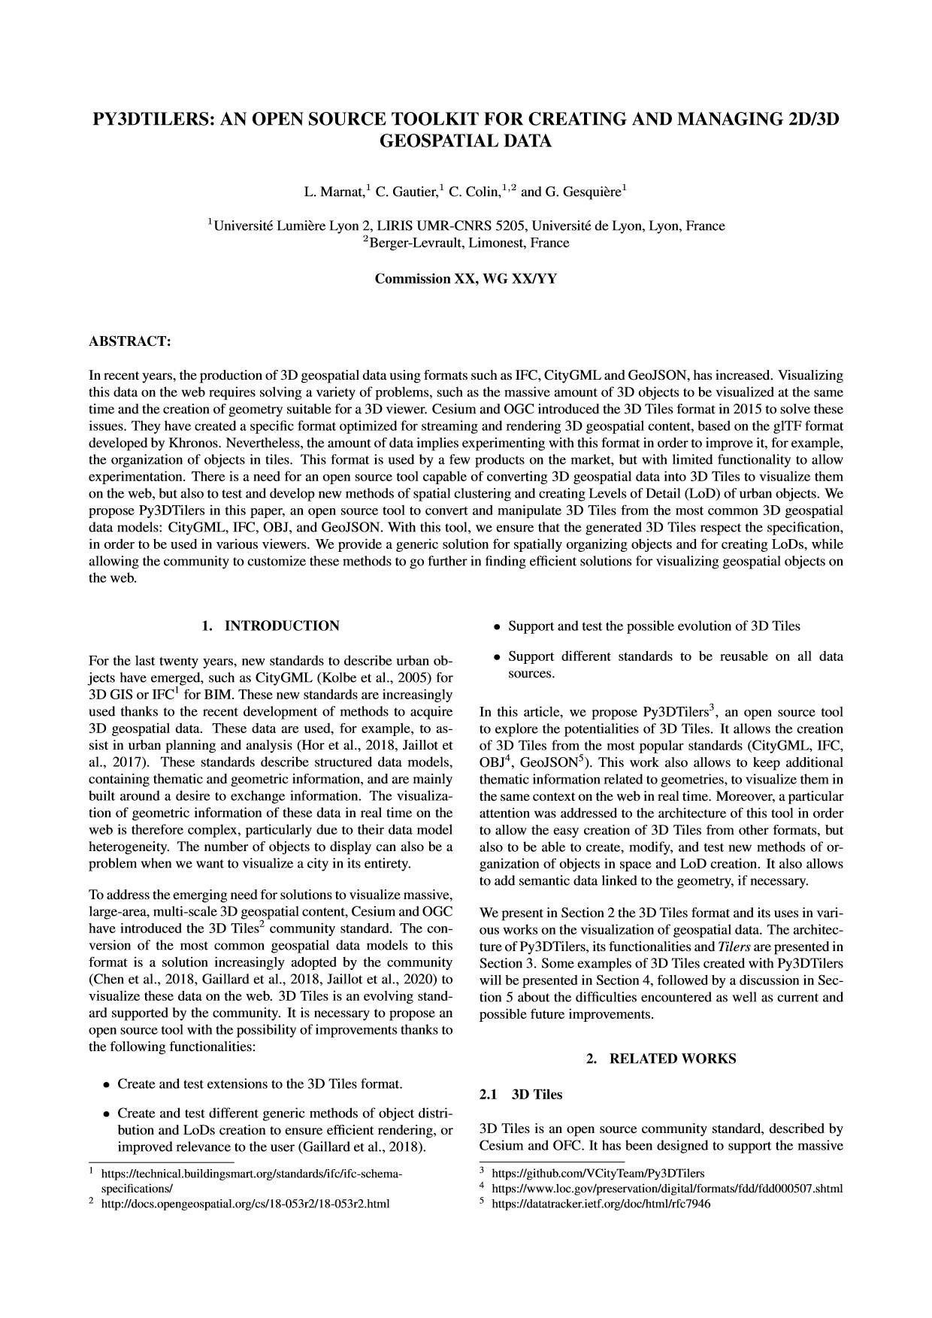

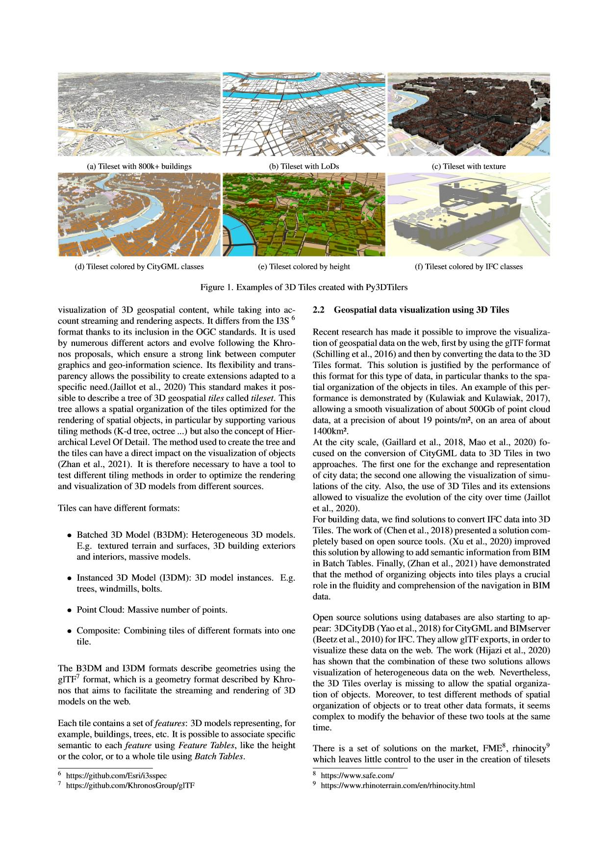

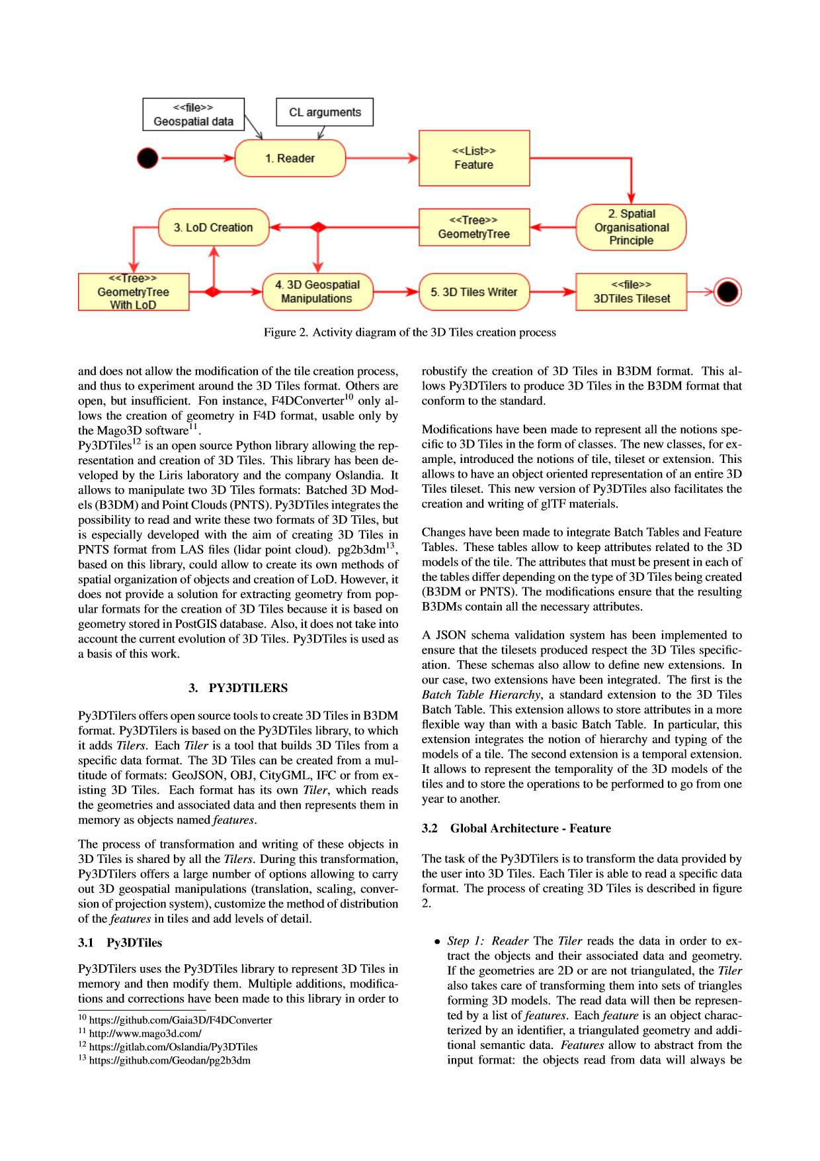

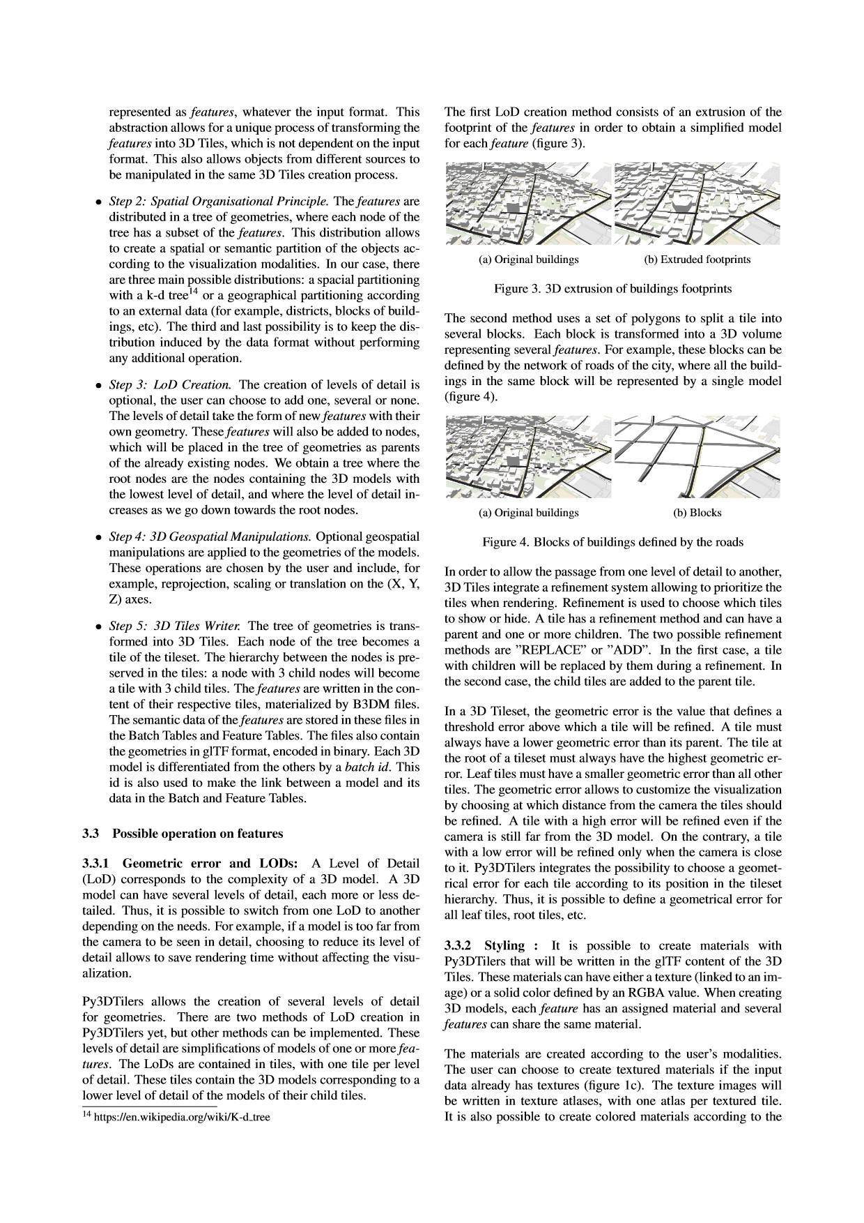

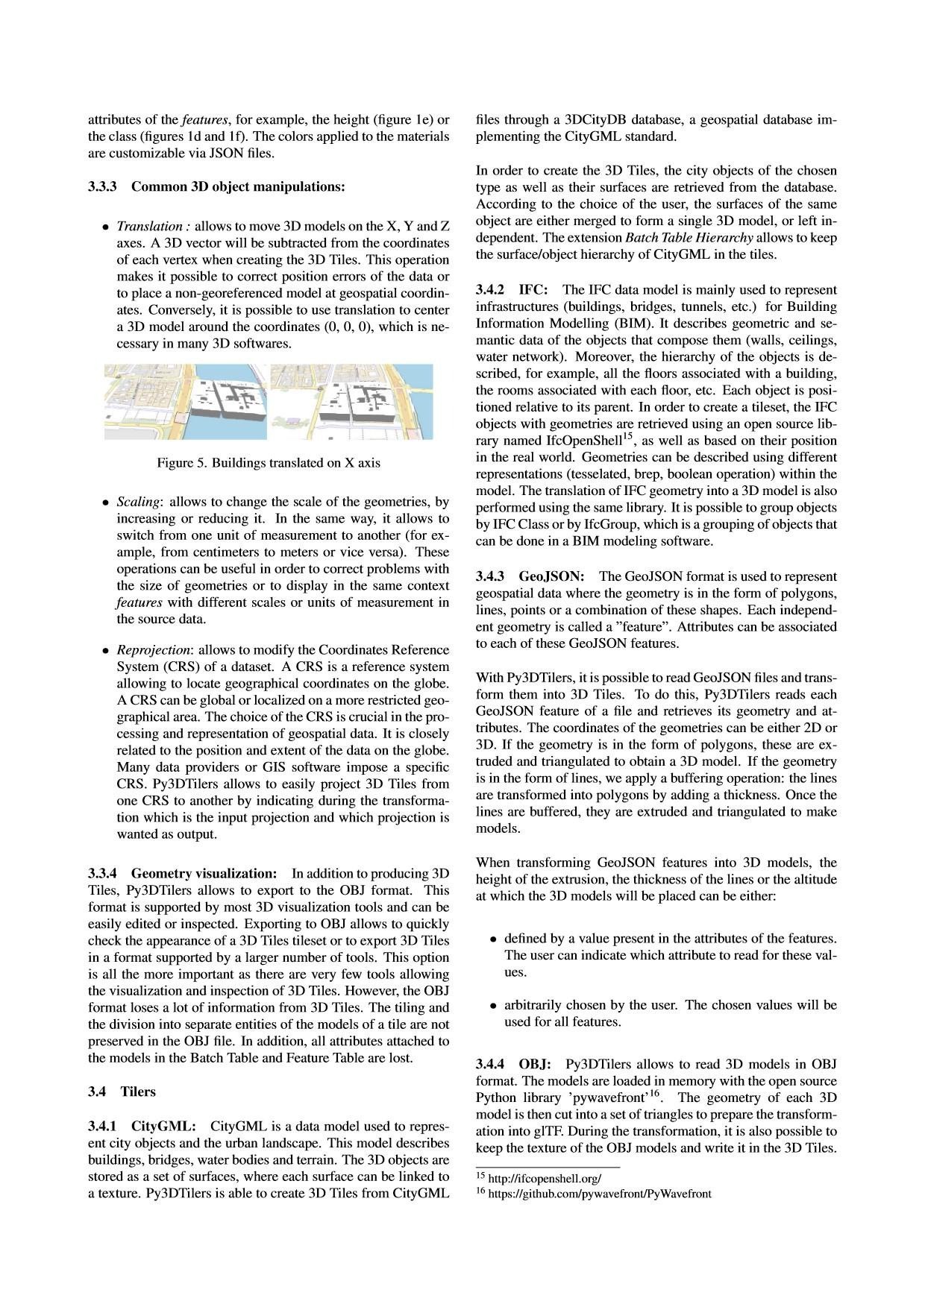

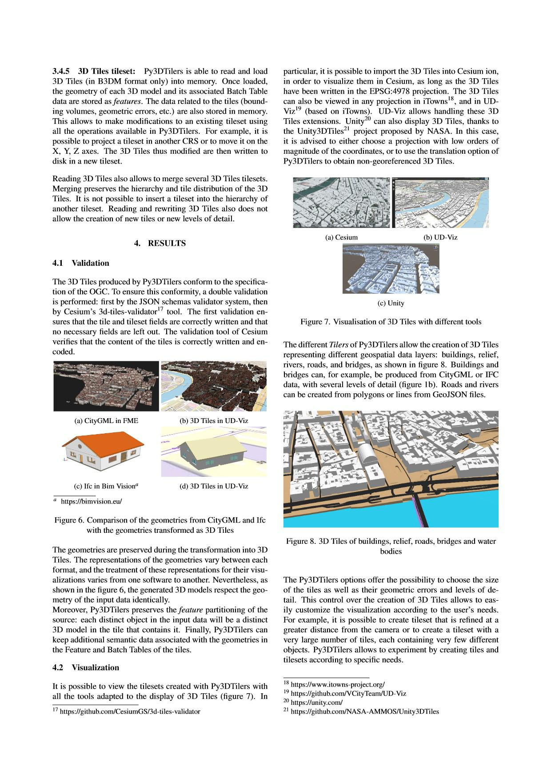

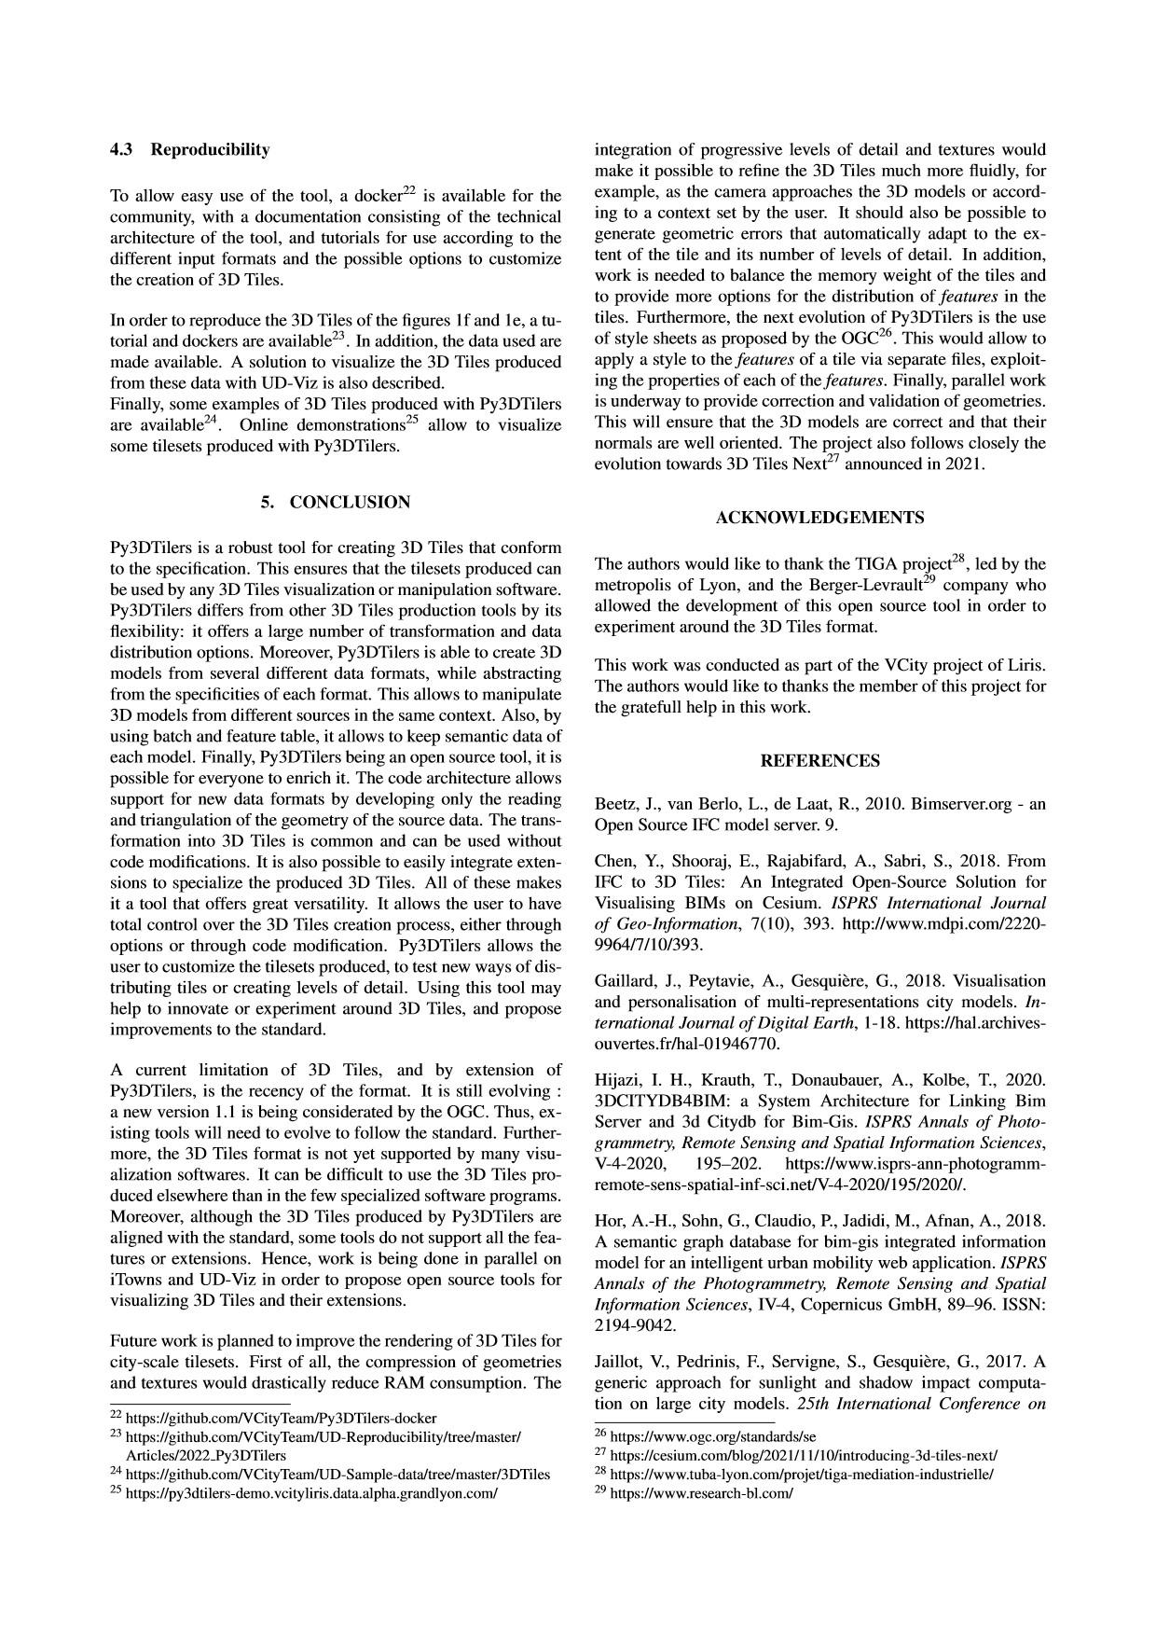

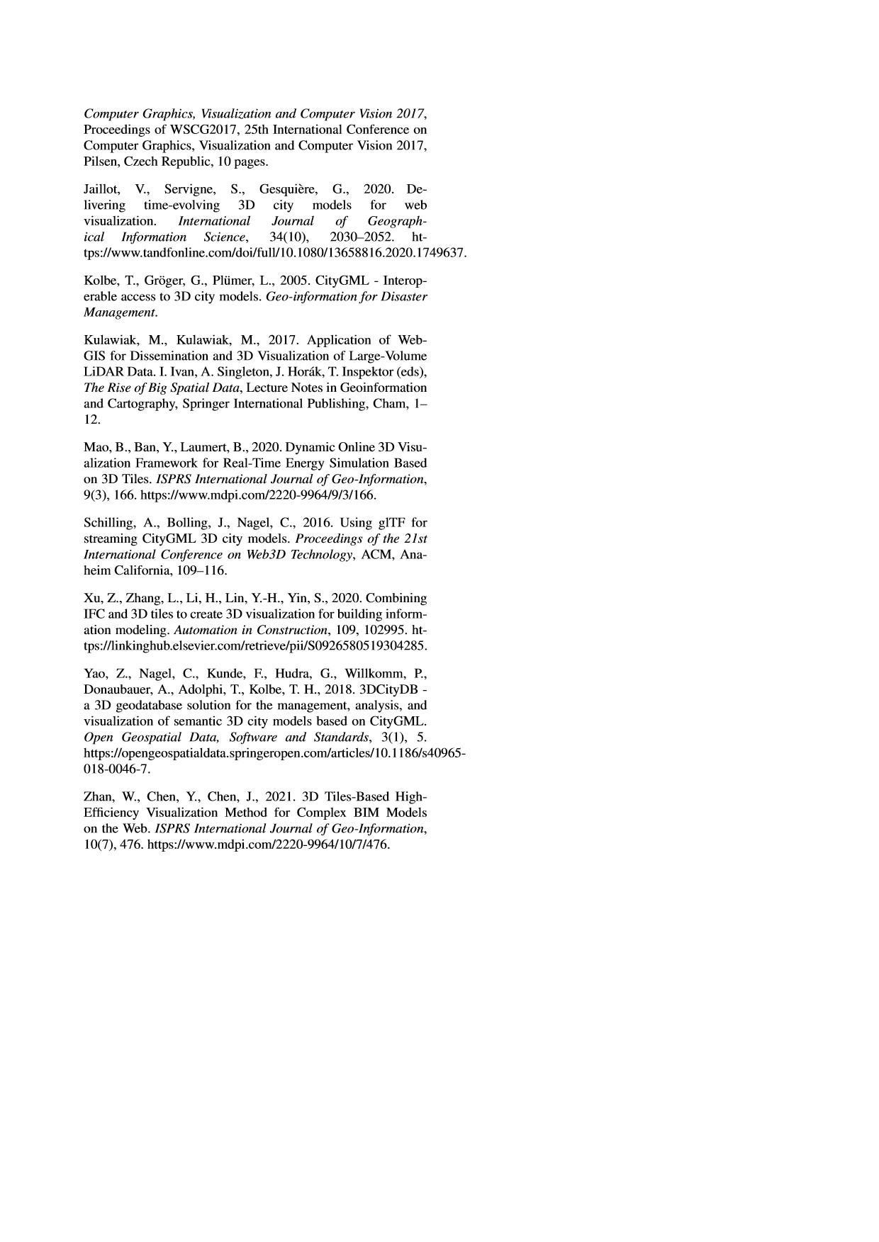

INTEGRATING MULTIMEDIA DOCUMENTS IN 3D CITY MODELS FOR A BETTER UNDERSTANDING OF TERRITORIES

Corentin Gautier1, Johanna Delanoy2, Gilles Gesquieres`3

* Universite´ de Lyon, LIRIS UMR-CNRS 5205, Universite´ de Lyon, Lyon, France - corentin.gautier@universite-lyon.fr 2 INSA Lyon, LIRIS UMR-CNRS 5205, Universite´ de Lyon, Lyon, France - johanna.delanoy@insa-lyon.fr
* Universite´ Lumiere` Lyon 2, LIRIS UMR-CNRS 5205, Universite´ de Lyon, Lyon, France - gilles.gesquiere@univ-lyon2.fr

Commission IV WG IV/9

KEY WORDS: Multimedia, Urban 3D model, Billboards, Documents, Story telling

ABSTRACT:

Digital 3D representations of urban areas, through their growing availability, are a helpful tool to better understand a territory. However, they lack contextual information about, for example, the history or functionality of buildings. On another side, multimedia documents like images, videos or texts usually contain such information. Crossing these two types of data can therefore help in the analysis and understanding of the organization of our cities. This could also be used to develop document search based on spatial navigation, instead of the classical textual query. In this paper, we propose four approaches to integrate multimedia documents in a 3D urban scene, allowing to contextualize the scene with any type of media. We combine these integration approaches with user guidance modes that allows to guide the user through the consumption of these media and support its understanding of the territory. We demonstrate the usefulness of these techniques in the context of different projects within the Lyon area (France). The use of multimedia documents integrated into a digital tour allows, for example, the iconic buildings to be contextualised or to understand the evolution of a territory through time.

1. INTRODUCTION

Digital 3D representations of urban areas are becoming widely available. Multiple tools exist to visualize them such as Google Earth1 or Cesium2. By allowing to wander into virtual cities, these tools allow a better understanding of a territory. However, most of them are limited to a 3D representation of the build-ings, without providing more information about their function-ality, their evolution or other elements of context. Aside from 3D representations, multimedia (e.g. images, texts or videos) also plays an important role in the understanding of the urban landscape. Archival images, videos on the history of a district, job descriptions of certain industries or interviews in a district can provide important additional information about a territory. While these media have the potential to enrich virtual 3D cities, the link between those multimedia and digital 3D representa-tions is rarely made.

Online mapping systems (e.g. Google Maps) allow to wander in a 2D or 3D view and pick information through labels or pins that simulate points of interest. By linking multimedia to a spa-tial position, users can find information more easily in a desired area. This can be seen as another form of search, rather than formulating a query on a web browser. As such, these tools lack ways to fully integrate the media into a 3D view of the city, and usually lack of explanatory media on the organisation of a district or a whole city, on its history, etc.

We propose a model that allows to combine a 3D view of the city in which the user can navigate with a collection of multi-media that provides additional information about the underlying 3D scene. We present new ways to integrate each multimedia document in the 3D scene as well as ways to guide the user

* https://www.google.com/intl/fr/earth/

2 https://cesium.com/

through a collection of different documents. More precisely, we introduce four modalities of multimedia integration in a scene (shown in blue in Figure 1) that are presented in Section 3:

* The 3D geo-pinned multimedia uses the principle of pins that target a point of interest and are linked to a multimedia document. Our extended pins gives an overview of the linked document.
* The 3D geo-web renderer shows documents at given pos-itions in the scene, always facing the camera such that the user can get the information from any place in the scene.
* The extended document superimposes images on a 3D model and complete them with textual data. The extended document is linked to a precise camera position.
* The slideshow allows to make a presentation in a view by placing documents in a 3D space.

A large number of documents linked in a scene do not neces-sarily guarantees a better understanding of a territory, as users might need to be guided through them in order to understand them. We thus present ways to guide the user through its con-sumption of documents in the scene. Our three user guidance modes range from a fully sequential order of consumption, to a free mode where the user can wander in the scene and pick the documents as he wishes. These modes and the way they can can be mixed with the multimedia integration modalities are presented in Section 4.

The combinations of the integration modalities and user guid-ance modes open the door to a large variety of choices in the way to use multimedia documents in combination with 3D vir-tual cities. We demonstrate the potentialities of several of these

combinations in the context of multiple projects developed in the city of Lyon (France) in Section 5. Such projects include a web-documentary that aims to deconstruct preconceived ideas about a territory or presentations about the future of a neigh-bourhood using a tangible model.

2. RELATED WORKS

Many tools exist to navigate in a virtual urban environment (Bleisch and Dykes, 2015, Boutsi et al., 2019, Jaillot et al., 2021). Thanks to the navigation in the scene, users can visu-alize a city or any 3D geometry under different angles. This can greatly help to better understand an urban space by virtu-ally navigating in it.

Other tools, such as web-documentaries, also allow to walk in an urban space and better understand it without making use of a 3D scene. These tools can target a wider audience as they are web-based and do not require any specific hardware. Their 2D representation of the digital territory is enhanced by addi-tional information such as video (”Correspondances” 3) or im-ages (”Balade au merlan” 4). However, these tools remain lim-ited in their interaction because of the 2D representation of the world that they carry. We would like to take up this spatial con-textualization of documents to the third dimension and integrate such documents in 3D walking tours.

Enhancing 3D scenes with multimedia documents have been used to show the evolution of a city through time (Jaillot et al., 2021, Chagnaud et al., 2016). Such documents can bring in-formation about the state of a city at a certain date through im-ages of buildings at different times or their chronology. These works have introduced several methods to visualize historical photo documents in a 3D scene, allowing to show the urban past but also the future planning of cities. However, they lack the possibility to provide additional information on these pic-tures to help reach a better understanding. They also do not allow to use any other type of media, such as videos of web pages, or to interact with them.

Other methods have tried to contextualise a digital model with quantitative data (Bleisch and Dykes, 2015) or text and images (Boutsi et al., 2019) in a scene. This gives another perspective on the data and a better understanding of a territory by linking information to a geospatial position. These methods are good examples on how a 3D representation and multimedia or data can complement each other. However, they only integrate one type of content and do not give an overview of the different documents present in the scene, making the search for a specific document or data harder. We want to provide a new method of document search through a digital representation of a territory by allowing an explicit overview of the different multimedia available.

Rather than images or data, web pages can also be integrated in a 3D context to contextualise a 3D scene (Wijnants et al., 2015). This allows giving the user access to more content, such as external websites, while not losing the focus on the digital representation of a territory. The interest of integrating the web page directly into the 3D scene is also to support the relation-ship between the target and its related annotation objects (Seo et al., 2015). While we follow the same goal, we aim to provide

* https://correspondances.tv5monde.com/

4 http://unebaladeaumerlan.fr/

a model that allow to integrate any type of multimedia in the scene and to bring information on a specific geometries like building or district (Samuel et al., 2016).

Multimedia documents can also have interesting metadata like their title, source, publication date, key content, tags. (Gan et al., 2014) gives an overview of the existing techniques used to visualize a multitude of documents both in 2D and 3D environ-ment. However, they do not target geographic applications and the integration in 3D urban scenes.

While integrating multimedia document in the 3D digital rep-resentation of the city can greatly improve the understanding of such area, the user can quickly be lost in this multitude of in-formation and not know where to start searching. Some works have shown the interest in guiding the user by making him fol-low a logical sequence of information. It also helps to engage the user and allow him to be more effective in its reading of the information (Othman et al., 2011). In our work, we com-bine methods to integrate multimedia into 3D urban scenes with ways to interact with a collection of documents, providing dif-ferent levels of guidance to the user.

Existing methods of integrating multimedia do not satisfy our need to manage multiple types of document or to provide in-teraction with them. We provide several ways to integrate such multimedia in the 3D scene, depending on the type of such doc-uments but also on their goal and content. These integration modes can be combined with user guidance modes that help reach better user experience and understanding of territory.

3. MULTIMEDIA INTEGRATION APPROACHES

Our objective is to integrate different types of multimedia docu-ments into a 3D urban scene in order to make the representation more informative and interactive. The integrated documents can thus be videos (eventually 360 videos) as well as images, textual documents or web pages, as shown in Figure 1. They are all georeferenced and have a position in space. Although this position is a natural link with the 3D scene describing the city, integrating the media visually in a simple interface such that the user can mentally connect them to the 3D representation of the city is not easy.

We propose four methods to integrate such documents in the 3D scene, explained thereafter and shown in blue in Figure 1. The choice of one of them depends on the type of media but also on their meaning or their number. This integration makes it possible to have all the information on a district on the same web interface, easing the understanding of such areas. But it can also help to find documents or information by wandering in the digital representation of the city and browsing the mul-timedia that are available. Each of these integration modalities can be used in the 3D scene with different user guidance modes (free access, conditional and sequential) that will be described in Section 4 and are shown in yellow in Figure 1.

The first two approaches (3D geo-pinned multimedia and 3D geo-web renderer) integrate a media into a 3D scene such that it is linked to a precise spatial location and always shown facing the camera (similar to the billboard technology). The extended document is linked to a camera position and superimposes the media to the 3D scene, while the slideshow projects a series of media onto a 3D plane in the scene. All of these methods aim to be integrated in a web-based library for 3D visualization of geographical data.

***Multimedia***

|  |  |  |  |  |  |  |  |  |  |  |  |  |  |  |  |  |
| --- | --- | --- | --- | --- | --- | --- | --- | --- | --- | --- | --- | --- | --- | --- | --- | --- |
|  |  |  |  |  | Text / Images / Videos / HTML pages | | | | | |  |  |  |  |  |  |
| ***3D integration modalities*** | | | |  |  |  |  |  |  |  |  |  |  | **Billboard** | |  |
|  |  |  |  |  |  |  |  |  |  |  |
|  |  |  |  |  |  |  |  |  |  |  |  |  |  |  |
|  |  |  |  |  | |  |  |  |  |  | |  |  |  |  |  |
| **Slideshow** | |  |  | **Extended document** | | |  |  | **3D geo-web renderer** | | |  | **3D geo-pinned mutlimedia** | |  |  |
| orientation | |  |  | opacity | | |  |  | size | | |  | activation status | |  |  |
| size | |  |  |  |  |  |  |  |  |  |  |  | screen position | |  |  |
|  |  |  |  |  |  |  |  |  |  |  |  |  | thumbnail image | |  |  |
| *georeferenced position* | |  |  | *camera position* | | |  |  | *georeferenced position* | | |  | *georeferenced position* | |  |  |
|  |  |  |  |  |  |  |  |  |  |  |  |  |  |  |  |  |

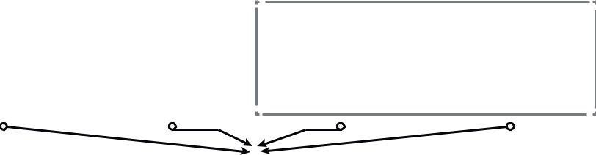

***User guidance***

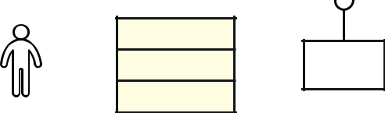

**User**

*Free access*

*Conditional access*



*Sequential access*

3D scene

Figure 1. Architecture diagram of our proposed model. The multimedia can be integrate in the 3D scene using one of the multimedia integration approaches (in blue). Each approach is characterized by attributes that allow to parameterize the integration. The media are linked to the scene by either a georeferenced position or a camera position (shown in italic). The user can consume the integrated media in the scene through different guidance modes (in yellow).

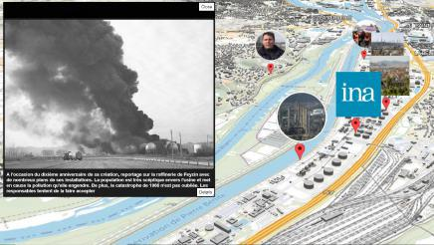

3.1 Billboard inspired approaches

These approaches consist in an arrangement of thumbnails dir-ectly shown in the 3D scene and targeting a precise spatial point. The thumbnail is always facing the camera such the user can access the information from any position in the scene. The two approaches differ in the way the document is displayed through the thumbnail: either directly or summarized in an in-teractive pin. In either cases, the integration is characterized by a georeference position (GPS coordinates).

The 3D geo-pinned multimedia is based on the principle of pins that target a point of interest. We enrich the traditional pin by adding a thumbnail above it that gives a visual feedback on the nature and content of the multimedia. This pin is meant to be interactive: when selected, the linked document appears in 2D on the screen in front of the 3D scene (see example in Fig-ure 2). The pin and its thumbnail are always facing the camera while the multimedia document is displayed as a 2D element that will not move with the camera. This approach allow to give the user a global vision of all the contents available in a scene. The user can then pick from this data and decide to get more de-tailed information about a place or building pointed out by the pins. The interactivity of the pin can be deactivated, allowing to control what the user can access as content at a given moment. In this case, the user can still see the pin and its thumbnail, thus knowing that there is a document accessible, but will not be able to consume the linked document. In addition to its spatial position, the 3D geo-pinned multimedia is thus also character-ized by its activation status, the position where to display the document on the screen and its thumbnail image (see Figure 1).

The 3D geo-web renderer also points to a precise location in the 3D scene but the linked document will be directly shown to the user when he approaches it. Again, the document will be displayed always facing the camera so that the user can see it from any position in the scene. This way, the user can continue walking around in the 3D scene and mentally put this document in context. An example of the integration of a web page with this approach is shown in Figure 3. The size the media appears in the 3D scene is an additional parameter in this integration method.

Figure 2. An example of the 3D geo-pinned multimedia approach. The pins show the available multimedia on the 3D scene while the selected document is shown on 2D at the left of the screen.

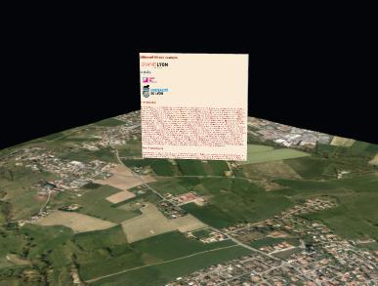

Figure 3. An example of the 3D geo-web renderer approach. An html page is shown over the 3D scene.

These two billboard approaches are similar in the way they are integrated into a scene, they both target a precise location in space and allow to quickly see which content is accessible while moving into the scene. However, by summarizing the informa-tion into small pins instead of directly showing it, the 3D geo-pinned multimedia allows to display more document without cluttering the space. It could thus be a preferred solution when

a large number of documents need to be shown in a small space.

3.2 Extended Document

The extended document approach displays a multimedia doc-ument in a 2D context on top of a 3D scene. The integration of the document in the 3D scene is done by modifying the position and orientation of the camera, rather than positioning the docu-ment in the 3D space (see Figure 4). In order to access different documents in the same scene, the user has to choose the doc-uments he is interested in in a list. When selected, the camera will move to the right position and overlay the document on top of the 3D scene. In order to keep the link with the 3D scene, the camera will move smoothly toward the target position, allowing the user to locate more easily its position in 3D. Documents in this approach are thus characterized by the position and orient-ation of the camera, as well as the opacity of the element to be overlaid.

The extended document is composed of three distinct windows:

* The navigator windows (Figure 4, left-most window) which allows to navigate between the different documents with their titles and reference dates. This window also has a filter system for a better navigation among the documents

.

* The inspector windows (Figure 4, right-most window) gives a preview of the document that will be superimposed in the 3D scene, as well as all additional information about it such as its description, source, and publication date. It allows the user to have a first understanding of the docu-ment and verify that it is the media that he wants to con-sume.
* The visualization windows (Figure 4, middle window) is activated when the user decides to engage the visualization in the inspector window. It will smoothly move the camera to the correct position and superimpose the document on the 3D view. It also allows to change the opacity of the document in order to compare it with the underlying 3D.

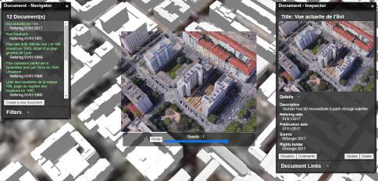

Figure 4. An example extended document with its three

windows: the navigator window showing the list of available documents (left); the inspector window showing the metadata of the selected document (right); the visualization window that superimposes the document on the 3D scene (middle).

This approach will be preferably used with images, or animated images, as it allows to directly compare it with the 3D view of the scene. It can help users to realize the evolution of a district or a building, or observe it under another format.

3.3 Slideshow

The slideshow is anchored at a 3D position in the 3D scene and can display the documents on a 3D plane (see Figure 5). This plane is traditionally parallel to the ground but can be also set vertically to contextualize face buildings. The documents will thus not follow the camera as the user move into the scene. The slideshow is characterized by its center position (georeferenced position), its size and its orientation. This method overlays the 3D model of buildings on top of the documents, that can be im-ages or videos of data layers on a district, or different states of a territory. For example, one could drop the image of the trans-port network of a city and see how it fits with the morphology of that city. The slideshow is made to integrate a series of doc-uments: it simulates a presentation in the 3D world in which one can scroll through different documents, located at the same place, in order to illustrate problems or ideas on a district. The user can easily drag and drop different images or videos into the scene, allowing to quickly illustrate different ideas, but also to work in team and experiment different solutions and illus-trations. A geographic mask is made available to prepare data directly in dedicated GIS information systems tools.

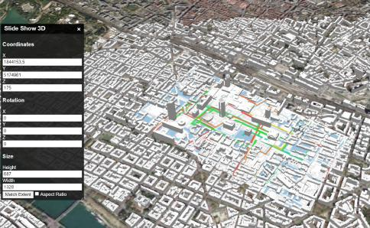

Figure 5. An example of the slideshow. The configuration

window (on the left) allows to set its parameters. One image of the slideshow is shown on a ground plane in the 3D scene.

4. USER GUIDANCE

Our different multimedia integration approaches allow to integ-rate a large variety of multimedia in a scene, from an archive image to a web page. When becoming too numerous in one scene, the user could get lost among them thus breaking the goal of our approach to bring a better understanding of a ter-ritory. We thus design several ways to consume a collection of documents, by possibly guiding the user through their con-sumption:

* Sequential access: The documents are provided in a given order. As in a guided tour, this allows to build a narrative and guide very precisely the user through the documents. This mode limits the order of freedom of the user, it can only act on the time to spend on each document, but helps to build a better understanding of the documents.
* Conditional access: Going through some documents might be needed to access others, but the order is not completely constrained. Several documents are available at one mo-ment in which the user can chose freely, but viewing some or all of them is needed to access the next ones.

* Free access: the user can consume the different multime-dia in the scene as he wishes.

Most of our integration approaches can be used with any of these user experiences, although some are more naturally suited for some specific user guidance. The only exception is the slideshow, that is essentially made for sequential access. It al-lows a linear succession of images or videos on a 2D map and can be used in the case of a presentation to contextualise a dis-trict.

The extended document, because it has smooth transitions between documents and is not anchored at a specific position in the 3D scene, is well suited to be used in a sequential approach. It can be used to build a guided tour as a list of extended doc-ument where each of them with be contextualized in the tour with additional text. It can, for example, consist of a sequence of documents that show the evolution of a district with photos from different eras.

Both the 3D geo-pinned multimedia and the 3D geo-web ren-derer can be used naturally with any of the guidance. However the 3D geo-pinned multimedia is well suited for conditional ac-cess thanks to its activation status. It allows the user to see all the contents that is available in the scene through the pins, but the activation of some of the documents can be conditioned to the viewing of other ones.

5. IMPLEMENTATIONS

We experimented our different approaches on various use cases around the city of Lyon (France). Each of these use cases mo-bilizes one of our multimedia integration approaches, combined with a user guidance mode, allowing a wide variety of user ex-periences. These implementations are implemented within the UD-Viz library5, a JavaScript library allowing to visualize, ana-lyse and interact with urban data.

5.1 Chemistry Valley: 3D geo-pinned multimedia

We demonstrate the use to the 3D geo-pinned multimedia in the context of a web-documentary, developed as part of a collabor-ation between a training center for the Chemistry industry In-terfora6 and the Lyon metropolis. This web documentary aims to make the citizens rediscover the area of the Chemistry Valley (South of Lyon, France) through a 3D digital wandering where the user can interact with documents arranged in the 3D scene.

A large number of media, from different types were to be set in the scene. As examples:

* A photographic observatory 7 of the Chemistry valley, con-sisting of a set of pictures of the chemistry valley from different angles.
* Additional layers as for instance bus lines, the atmospheric index, etc. can be used thanks to numerous data available via WFS (Web Feature Service) and WMS (Web Map Ser-vice) in the open data data.grandLyon.com8.
* https://github.com/VCityTeam/UD-SV

6 https://www.interfora-ifaip.fr/

7 https://www.caue69.fr/1/page/10622/page

8 https://data.grandlyon.com/

Figure 6. The 3D geo-pinned multimedia modality used in the context of the Chemistry valley. The pins show an overview of the different media available in the scene.

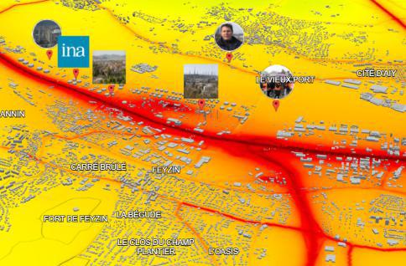

* Jobs descriptions located in the chemistry area. These pdf files provide information on workers in the area.
* Videos of stakeholder interviews in the Chemistry valley on the theme of employment and training.

The 3D geo-pinned multimedia is the best choice in this case since it allows to easily navigate between a large number of media, without cluttering the scene. Additionally, some of these media must be seen before others in the project specifications, naturally leading to using a conditional access mode. This also claims in favor of using the 3D geo-pinned multimedia.

|  |  |  |  |
| --- | --- | --- | --- |
| " episode -1 - data ": { | | | |
| " content - | 1" | : { |  |
| " lock " : false , | | | // document a c t i v a t i o n |
| " position " | | : { // c o o r d i n a t e s in the scene | |
| " x " : " | 1843554 | | .77", |
| " y " : " | 5165405 | | .73", |
|  |  |  |  |
| " z " : " | 220 | " |  |
|  |  |  |  |

} ,

" im g Un lo ck ": "./ assets / img / O b s e r v a t o i r e /

cheminee . jpg ",

" imgLock " : "./ assets / img / O b s e r v a t o i r e /

cheminee . jpg ",

" text " : " Vallee de la chimie -

O b s e r v a t o i r e p h o t o g r a p h i q u e " ,

" src ": " https : // umap . o p e n s t r e e t m a p . fr / fr /

map / vallee - de - la - chimie "

}

Figure 7. An example of a JSON configuration file used for the 3D geo-pinned multimedia.

The conditional access allows to prioritise some contents, espe-cially for the interviews that were created specifically for this experience. These videos were made to be seen in a given order in order to understand the whole issue. As a reminder, in the 3D geo-pinned multimedia modality, documents can be natur-ally deactivated.. Their pin and thumbnail are still shown on the 3D scene but the user can not interact with them to access the document. In order to better guide the user towards the access-ible content, we symbolize the deactivation of the media by a lock image superimposed to the thumbnail. An example of a visualization of the Chemistry valley in this project can be seen in Figure 6: the atmospheric index is used as a color map on the

ground of the 3D model while several pins show the available content.

Each interactive element in this scene can be configured through a JSON file that contains the geospatial position, the display thumbnail, its activation status, the text content and the docu-ment link. An example of such configuration file can be seen in Figure 7.

The integration of multimedia in the 3D scene makes it possible to show the different professions that exist in the Chemistry valley, and help the users to know more about the Chemistry industry in this territory. To further this understanding, we have also integrated urban data into the scene by using geoservices9, spatial web services that make geodata available in a structured form. Finally, in order to show the valley differently, we have integrated WMS (Web map service) and WFS (Web feature ser-vice) which allow the display of georeferenced geometries such as building cadastres.

Thanks to the 3D geo-pinned multimedia method, we have brought another form of information search through the wandering in the 3D scene. The user can pick up interviews with the stake-holders of this territory and get information on where they are located and which company they belong to before even starting to watch the video. This makes it easier for him to choose the content that interests him.

5.2 Flying campus: 3D geo-web renderer

We use the 3D geo-web renderer method in the context of the project ”IMUV/Flying campus”10. The aim of this project is to create a virtual space in which photographic exhibitions, con-ferences, or other events can be organised. It is an interactive space, floating above the city, where a variety of elements can be arranged and where several users can gather. Elements to be displayed can be of any types, including web pages. The use of the 3D geo-web renderer allow to integrate any type of media into the 3D space, such that the user can still be in im-mersion while consuming the content. One of the use case is a conference room in which a 3D geo-web renderer is placed to broadcast a video, the users can gather in the room and freely interact with the video. Figure 8 shows a user observing the city in 3D while looking at a map showing the organisation of the city.

Figure 8. An example of the use of the 3D geo-web renderer in ”Flying campus”, a virtual gathering place. The user can still observe the 3D scene while the integrated multimedia is shown to the user.

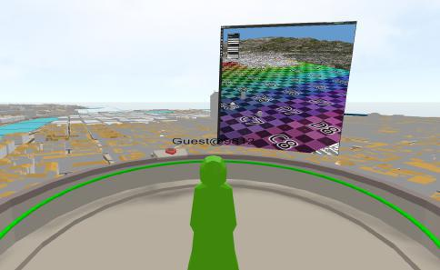

In this context, the user is free to consume the content of these multimedia as he wishes and is not limited by an order to follow (free access).

Flying campus demonstrates the value of this multimedia in-tegration as a way to virtually share multimedia experience and build participative experiences.

5.3 Historical guided tour: Extended document

In this project, we use the extended document as a way to show the evolution of a district over time. Our goal was to integ-rate a collection of archival photos from 1760 to 2017 in the 3D scene. Each picture shows how the district looked like at a specific date along with additional information. By allowing to superimpose the picture on top of the 3D scene, at its correct po-sition, the extended document is naturally suited for this kind of use cases. By playing on the opacity slider, the user can more easily observe the morphological evolution of a building or a district between two periods. An example showing the histor-ical organisation of a district with some additional information is shown in Figure 9

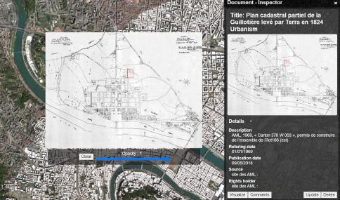

We implemented the 3D geo-web renderer using the CSS3Drenderer technology (a web rendering method from the javascript library ThreeJS11) that allows to include web pages, with which the user can interact, in the 3D scene. Our implementation con-sists in an overlay of two types of rendering: a CSS3Drenderer which shows the document to be displayed and the WebGLRen-derer which is the 3D scene rendering of the walkthrough (Seo

et al., 2015). We make a part of the 3D scene rendering trans-parent and render the CSS3DRenderer context behind the WebGLRen-derer context. This allow the content of the document in the CSS3DRenderer to appear in the 3D scene.

By placing these billboards in the 3D scene of the flying cam-pus, the user does not loose focus and has all the information in one web application. If the document to integrate is a web page, the user can freely interact with it as if it was facing the window of a web browser.

* https://geoservices.github.io/

1. https://demo.liris.cnrs.fr/vcity/flyingcampus/
2. https://threejs.org/

Figure 9. An historical cadastral plan is shown superimposed on top of the 3D scene by using the extended document modality.

To bring more coherence between these documents, we used the sequential access mode as a user guidance. We thus de-veloped a guided tour in which the user can follow the chro-nological evolution of the district and better understand how it has evolved through the ages.

maquettes–247850.kjsp?RH=1633680335198

12 https://ecoleanthropocene.universite-lyon.fr/a-quoi-revent-les-

[Billboard.html](https://github.com/VCityTeam/UD-Viz/blob/master/examples/Billboard.html)

This use case allowed us to provide information about the evol-ution of a district thanks to archive images and the integration in the 3D scene.

* Historical guided tour using the extended document ap-proach: [https://github.com/VCityTeam/UD-Demo-](https://github.com/VCityTeam/UD-Demo-VCity-Spatial-multimedia-db-Lyon)VCity-[Spatial-multimedia-db-Lyon](https://github.com/VCityTeam/UD-Demo-VCity-Spatial-multimedia-db-Lyon). The docker can be found

|  |  |  |
| --- | --- | --- |
|  | at [https://github.com/VCityTeam/UD-Demo-VCity-](https://github.com/VCityTeam/UD-Demo-VCity-Spatial-multimedia-db-Lyon) |  |
| 5.4 Gratte-Ciel project: Slideshow | [Spatial-multimedia-db-Lyon](https://github.com/VCityTeam/UD-Demo-VCity-Spatial-multimedia-db-Lyon) |  |
| We use the slideshow approach in the context of an event or- | • Gratte-ciel project with the slideshow approach: [https:](https://github.com/VCityTeam/UD-Demo-Anthropocene-GratteCiel-) |  |
| [//github.com/VCityTeam/UD-Demo-Anthropocene-GratteCiel-](https://github.com/VCityTeam/UD-Demo-Anthropocene-GratteCiel-). |  |
| ganized during the Anthropocene week12. Several multidiscip- |  |
| The docker can be found at [https://github.com/VCityTeam/](https://github.com/VCityTeam/UD-Demo-Anthropocene-GratteCiel-docker) |  |
| linary students (Geomatician, urban planner, information- com- |  |
| [UD-Demo-Anthropocene-GratteCiel-docker](https://github.com/VCityTeam/UD-Demo-Anthropocene-GratteCiel-docker) |  |
| munication) gathered on the issue of using a tangible or digital |  |
|  |  |
| model as a technological tool for the intelligibility of territor- | Some demos are provided as dockers to ease their deployment. |  |
| ies. The students produced images or videos as an information |  |
| All the source code is accessible such that the different integra- |  |
| layer over a district of Lyon, that they could contextualize with |  |
| tion methods can be exploited in other contexts. |  |
| the 3D model of the same district. Three examples of such lay- |  |
|  |  |
| ers are shown in Figure 10. The images were produced such | 6. CONCLUSION |  |
| that they fit the underlying 3D geometry and can thus be su- |  |
| perimposed with it. The slideshow method allows to see the |  |  |
| geometry of building on top of these layers, allowing to better | Multimedia documents play an important role in understanding |  |
| understand the interaction between those buildings and the data | the urban landscape. We have presented several ways to integ- |  |
| represented in the different layers. | rate multimedia in a 3D scene in order to bring a better under- |  |
|  | standing of a territory. We also introduced different user guid- |  |
| The students could drop their vizualisations onto the 3D map | ance modes, going from a fully guided sequence up to a free |  |
| and animate a presentation by going through the different maps. | consumption of media, than can be combined with our multi- |  |
| They have proposed still image of geographic data or animated | media integration modalities. Different use-cases around real |  |
| simulation with multi-agent model. | project allowed us to demonstrate the variety of user experi- |  |
|  | ences that can be created with these approaches. The addition |  |
| The aim of this project was also to show how tangible models | of multimedia in the urban digital model brings another dimen- |  |
| could help in understanding urban projects. In addition to the | sion to it, and greatly improve the way user can understand and |  |
| 3D scene, we also provided the students with a tangible model | discover a territory. |  |
| of the neighbourhood that was built using white Legos. The | We currently demonstrated use cases making use of a unique |  |
| white color allows to easily project information into the model. |  |
| integration approach for all the media in the scene, but the dif- |  |
| Rather than only seeing their maps in the digital 3D scene, stu- |  |
| ferent approaches can be combined in the experience. |  |
| dents could project them onto the tangible model. Figure 11 |  |
|  |  |
| shows an example projection on the model. We calibrated a | While our integration approaches can cover various scenario |  |
| video-projector such that the 3D scene in UD-Viz was match- |  |
| and multimedia types, it might be complicated to find the right |  |
| ing with the tangible model, and we projected the slideshow |  |
| integration method for a given use case. It is also not clear yet |  |
| module on the model. Using the slideshow on a tangible model |  |
| what are the exact effects on the user experience for each of |  |
| allows to more easily understand and discuss about the interac- |  |
| these modes. Additionally, while our user guidance approach |  |
| tion between the building and other data. |  |
| helps the user to find its way in presence of a lot of content, |  |
|  |  |
| In these examples, we could observe the interest in adding an | a filtering or grouping system would also prove useful. Being |  |
| able to assign themes or time period to the different contents |  |
| image to a 3D scene and having a way to present information |  |
| would allow the user to filter the different media, but also to |  |
| linked to the 3D world. The mix of 3D modelling of buildings |  |
| group them in the scene and develop new modalities to interact |  |
| and videos or map backgrounds allowed to better understand |  |
| with them. For example, linking the multimedia with a time |  |
| the problematic of the district and the possibilities of the new |  |
| period would add a fourth dimension to the scene, allowing to |  |
| urban project. |  |
| travel through time in the scene. The user could then observe |  |
|  |  |
| 5.5 Building an home made application | the evolution of a district or a building by navigating through |  |
| documents of different ages. |  |
| All the described components are delivered as open source con- | REFERENCES |  |
| tent available at <https://github.com/VCityTeam/UD-Viz>. |  |
|  |  |
| Each of the demonstration project can be tested using the fol- | Bleisch, S., Dykes, J., 2015. Quantitative data graphics in 3D |  |
| lowing links: |  |
| desktop-based virtual environments – an evaluation. Interna- |  |
|  |  |
|  | tional Journal of Digital Earth, 8(8), 623–639. |  |

* Chemistry valley project using the 3D geo-pinned multi-

media: [https://github.com/VCityTeam/UD-Demo-](https://github.com/VCityTeam/UD-Demo-TIGA-Webdoc-ChemistryValley)TIGA- Boutsi, A.-M., Ioannidis, C., Soile, S., 2019. Intercative on-

|  |  |  |
| --- | --- | --- |
| [Webdoc-ChemistryValley](https://github.com/VCityTeam/UD-Demo-TIGA-Webdoc-ChemistryValley) | line visualization of complex 3D geometries. The International |  |
|  | Archives of the Photogrammetry, Remote Sensing and Spatial |  |
| • Flying campus using the 3D geo-web renderer: [https://](https://github.com/VCityTeam/UD-Viz/blob/master/examples/Billboard.html) | Information Sciences, XLII-2/W9, 173–180. |  |
|  |  |

[github.com/VCityTeam/UD-Viz/blob/master/examples/](https://github.com/VCityTeam/UD-Viz/blob/master/examples/Billboard.html)Chagnaud, C., Samuel, J. S., Servigne, S., Gesquiere,` G.,

2016. Visualization of Documented 3D Cities. The Eurograph-ics Workshop on Urban Data Modelling and Visualisation, UDMV 2016, Proceedings, Liege,` Belgium, 87–93.

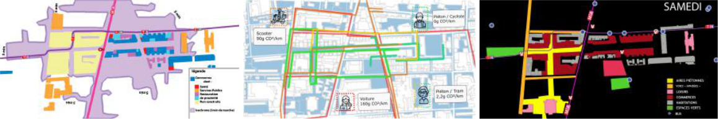

Figure 10. Three examples of image layers created by students for the slideshow. These layers can be used one after another in a presentation.

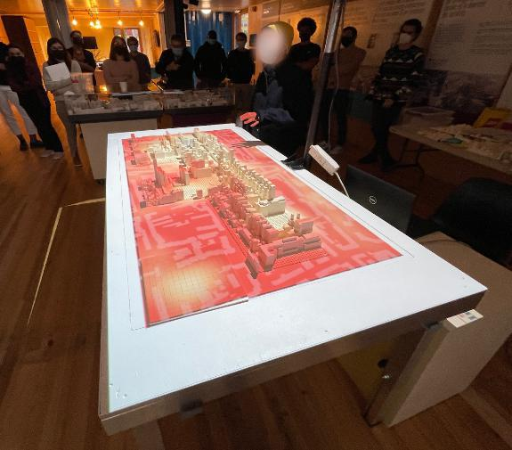

Figure 11. One image of the slideshow projected onto the

tangible model.

Gan, Q., Zhu, M., Li, M., Liang, T., Cao, Y., Zhou, B.,

2014. Document visualization: An overview of current re-

search. Wiley Interdisciplinary Reviews: Computational Stat-

istics, 6.

Jaillot, V., Rigolle, V., Servigne, S., Samuel, J. S., Gesquiere,`

G., 2021. Integrating multimedia documents and time-evolving

3D city models for web visualization and navigation. Transac-

tions in GIS, 25(3), 1419–1438. Publisher: Wiley.

Othman, M. K., Petrie, H., Power, C., 2011. Engaging Visitors

in Museums with Technology: Scales for the Measurement of

Visitor and Multimedia Guide Experience. Human-Computer

Interaction – INTERACT 2011, 6949, Springer Berlin Heidel-

berg, Berlin, Heidelberg, 92–99. Series Title: Lecture Notes in

Computer Science.

Samuel, J., Perinaud,´ C., Gay, G., Servigne, S., Gesquiere,`

G., 2016. Representation and Visualization of Urban Fabric

through Historical Documents. E. D. L. ISBN 978-3-03868-

011-6 (ed.), 14th Eurographics Workshop on Graphics and Cul-

tural Heritage, Proceedings of 2016 - Eurographics Workshop

on Graphics and Cultural Heritage, Genova, Italy, 157–166.

Seo, D., Yoo, B., Ko, H., 2015. Webized 3D experience by

HTML5 annotation in 3D web.

Wijnants, M., Erum, K., Quax, P., Lamotte, W., 2015.

Web-mediated Augmentation and Interactivity Enhancement of

Omni-directional Video in Both 2D and 3D.